LAB 1 : Data Query Language

1. select ename, sal, deptno from emp

where deptno=20 or deptno=30 or deptno=40;

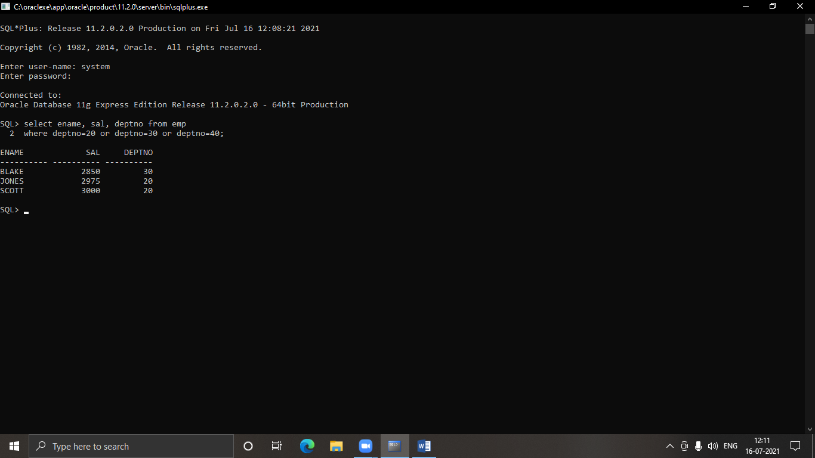

2. select empno as employee_number,ename as employee_name,Job as JOB,mgr as mgr,hiredate as dateof_joining,sal as salary,comm as commercial,deptno as department_number from emp;

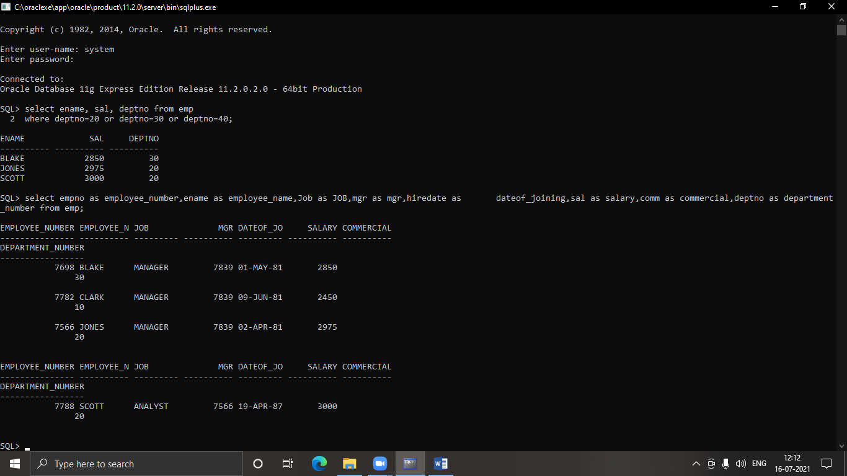

3. select student_code, sub1, sub2, sub3, sub1+sub2+sub3 as total from student_marks;

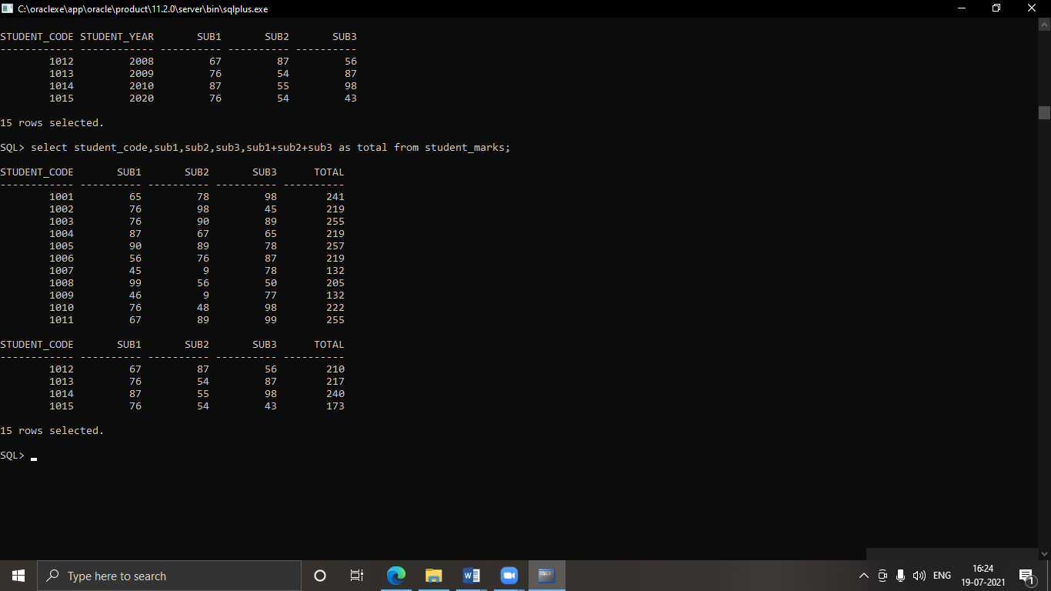

4. select * from designation_master where design_name =’Professor’ or design_name=’Leacturer’;

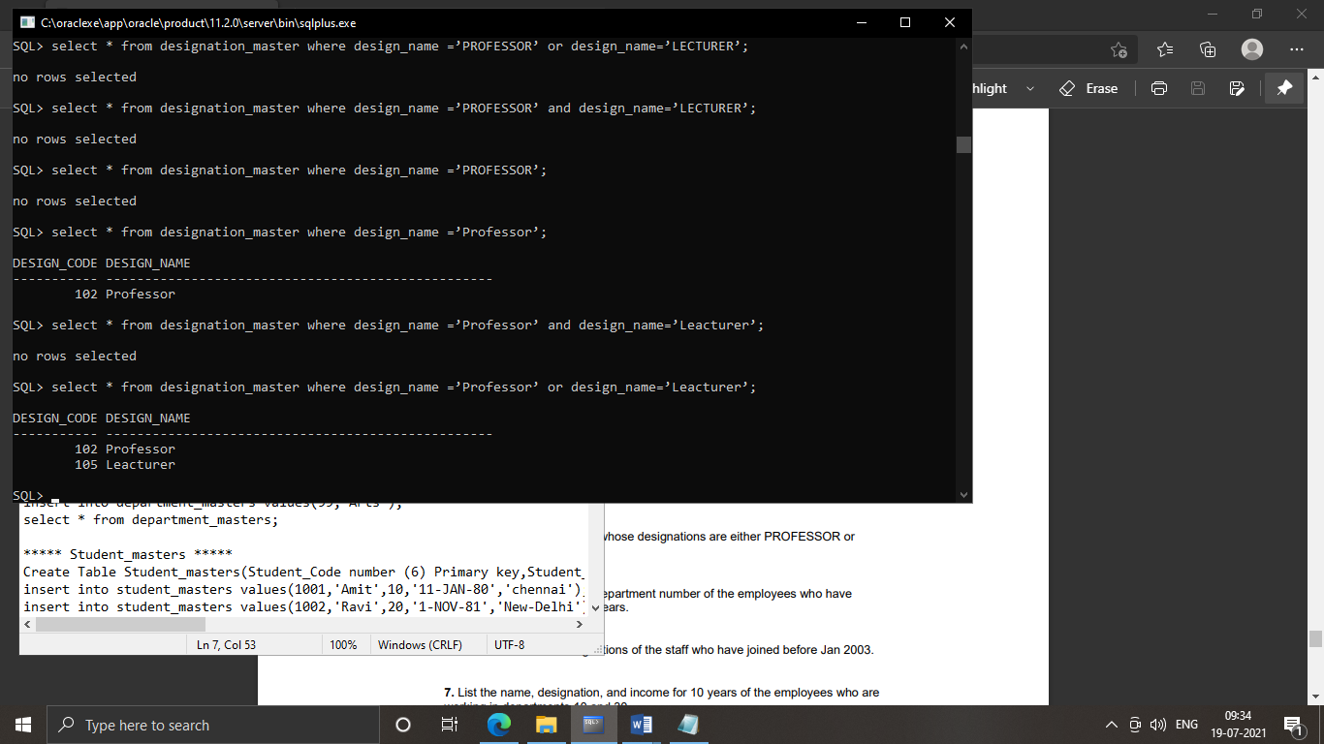

5. select ename,hiredate from emp

where (select extract(year from sysdate) from dual)-extract(year From hiredate)>18;

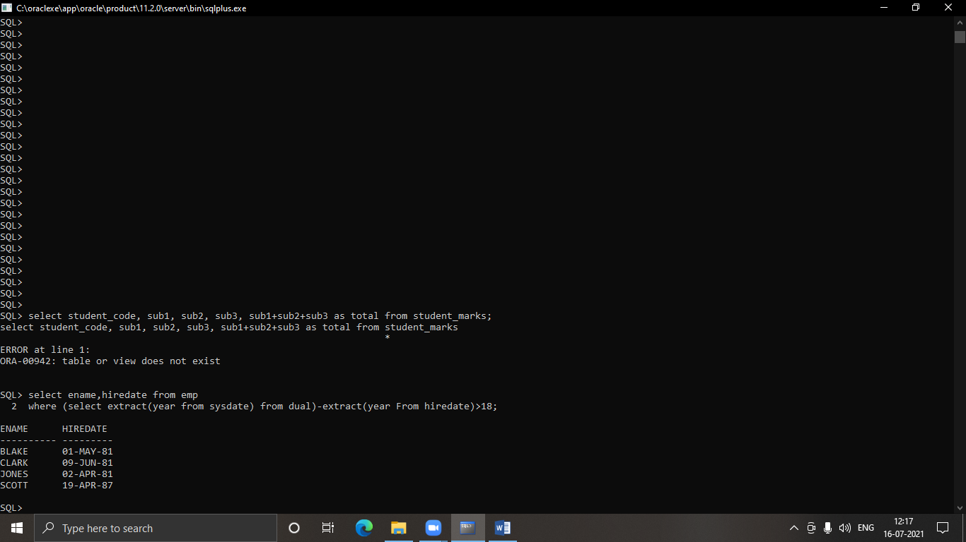

6. select staff_name,design_name from staff_masters join designation_master on

staff_masters.staff_code = designation_master.design_code where hiredate<’1-Jan-2003’;

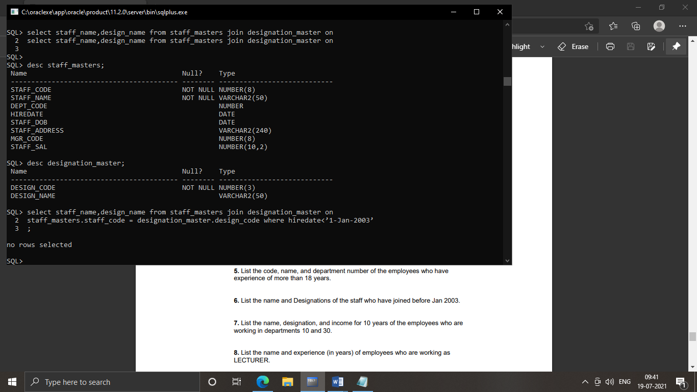

7. select ename,dname,sal,sal*12*10 as Updatesal from emp join dept on emp.deptno=dept.deptno where deptno in(10,30) ;

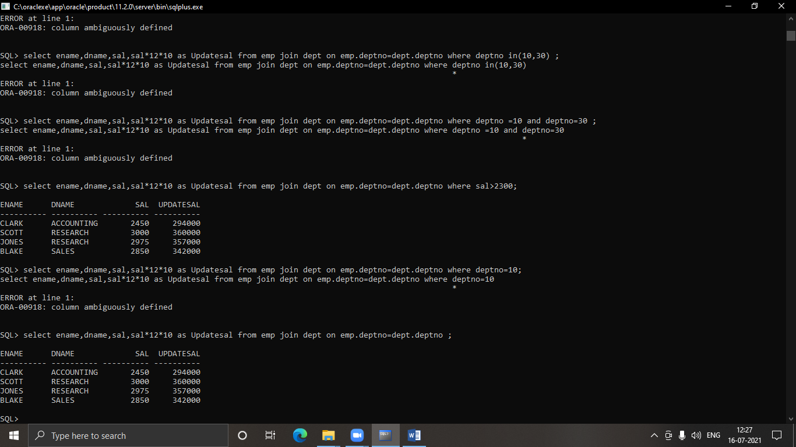

8. select staff_name,design_name,(select extract(year from sysdate) from dual) - extract(year from hiredate) from staff_masters join designation_master on staff_masters.staff_code=designation_master.design_code where design_name='Leacturer';

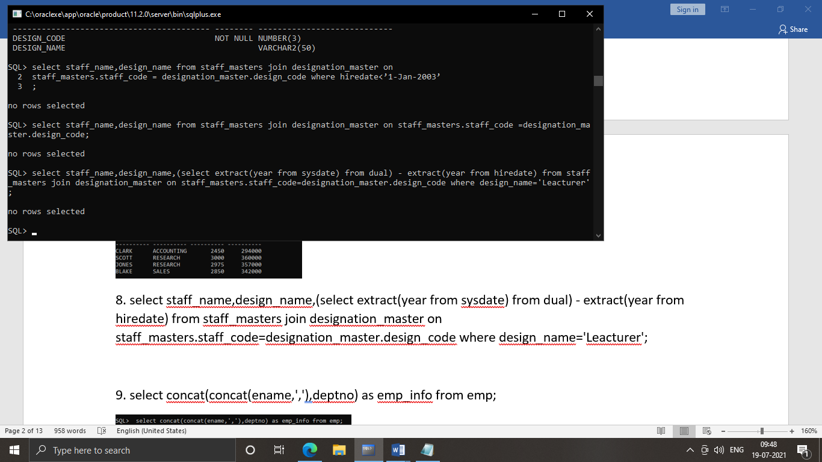

9. select concat(concat(ename,','),deptno) as emp_info from emp;

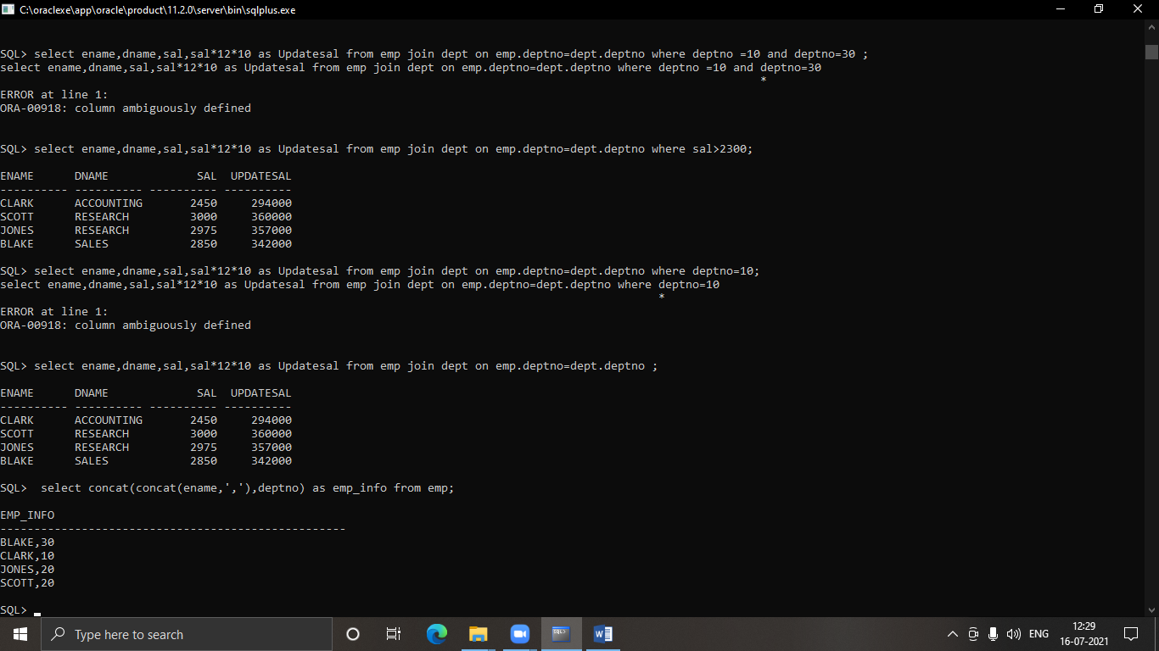

10. select ename,sal from emp

where sal between 12000 and 25000 order by sal, ename;

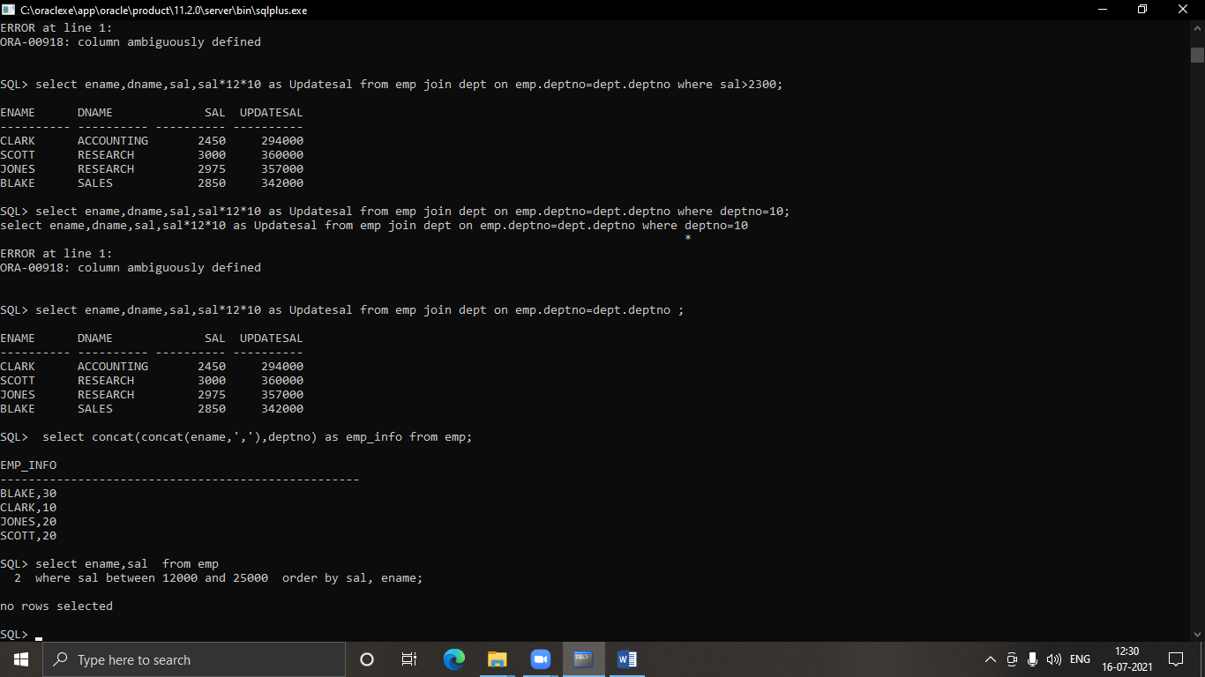

11. select * from emp where mgr is null;

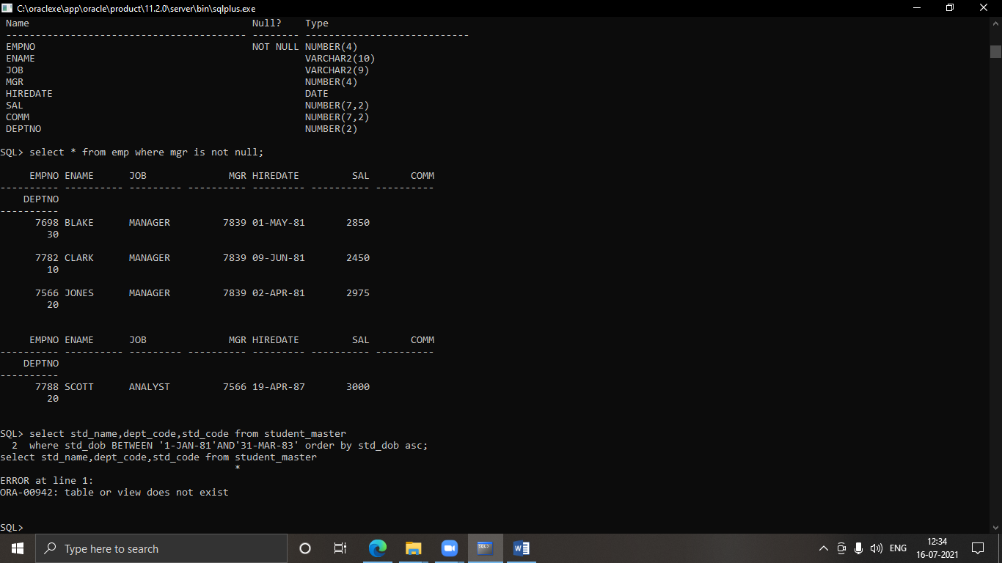

12. select student_name,dept_code,student_code from student_masters where student_dob BETWEEN '01-JAN-81' AND '31-MAR-83' order by student_dob asc;

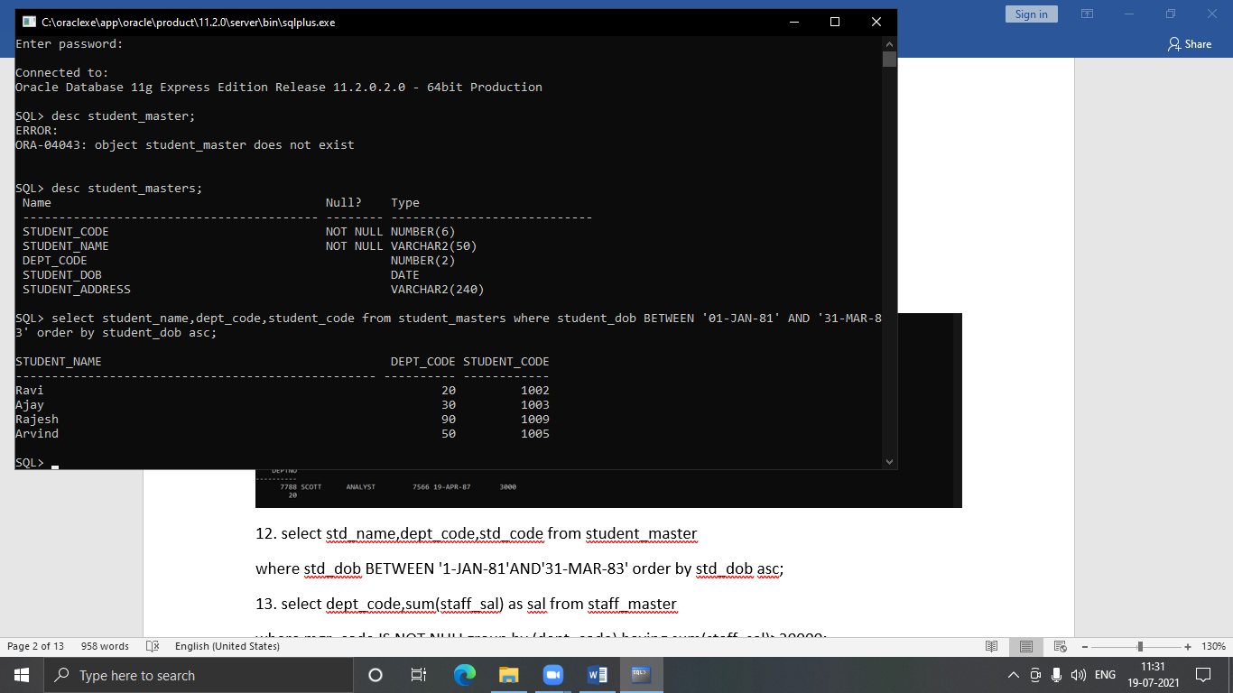

13. select dept_code,sum(staff_sal) as sal from staff_master

where mgr_code IS NOT NULLgroup by (dept_code) having sum(staff_sal)>20000;

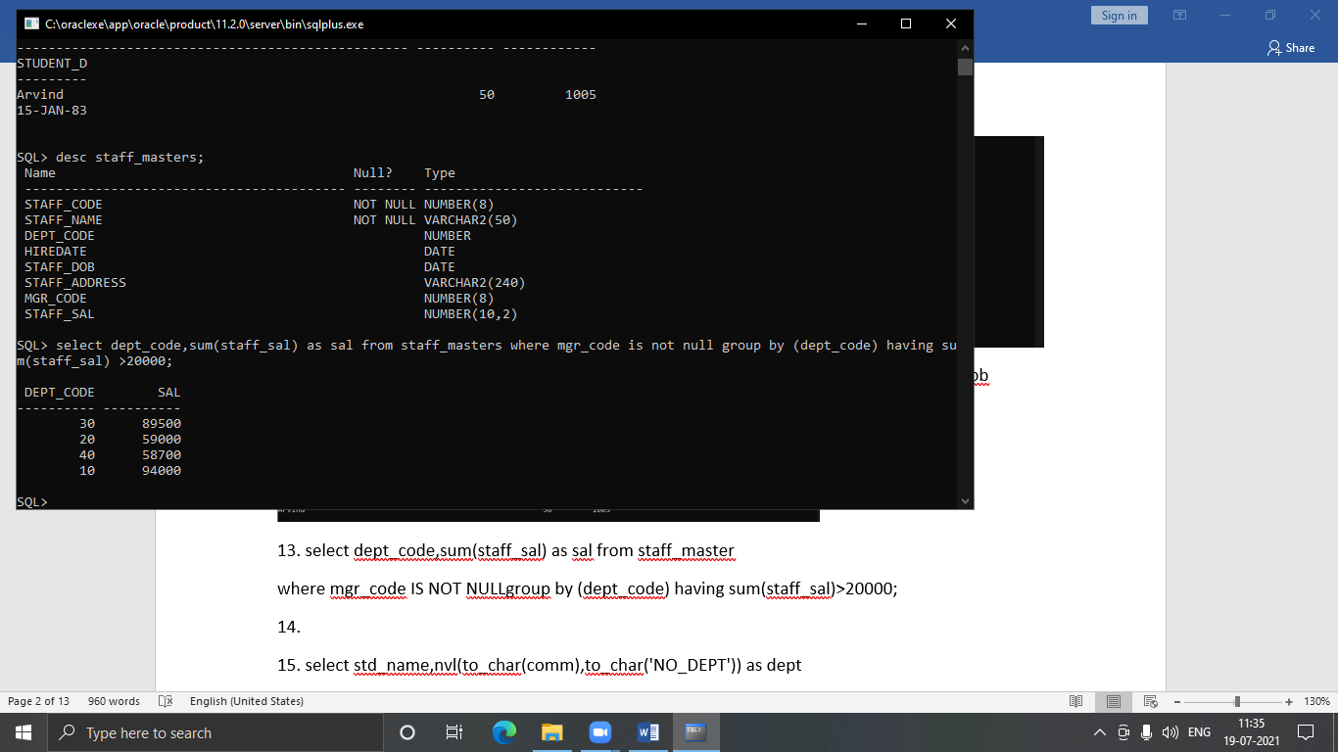

14. select * from book_transcations where BOOK_ACTUAL_RETRUN_DATE is null and BOOK_EXPECTED_RETURN_DATE='26-DEC-16';

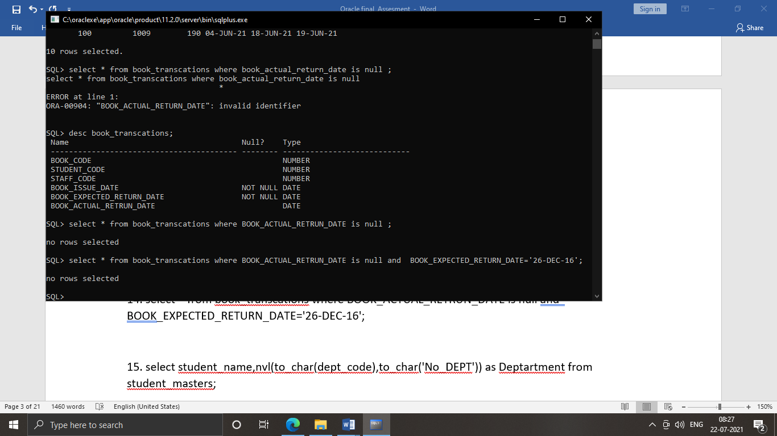

15. select student_name,nvl(to_char(dept_code),to_char('No_DEPT')) as Deptartment from student_masters;

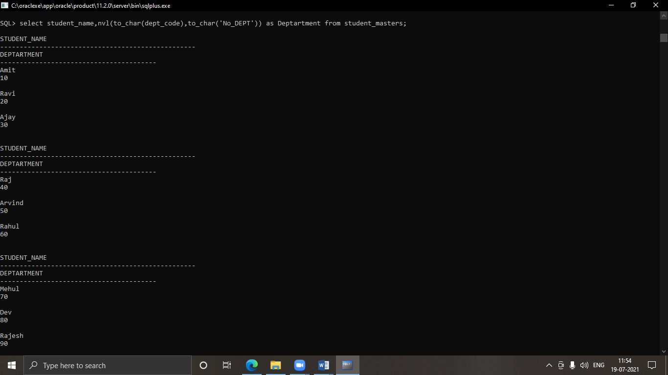

16. select ename,sal,lpad('X',sal/1000,'X')as XXX

from emp;

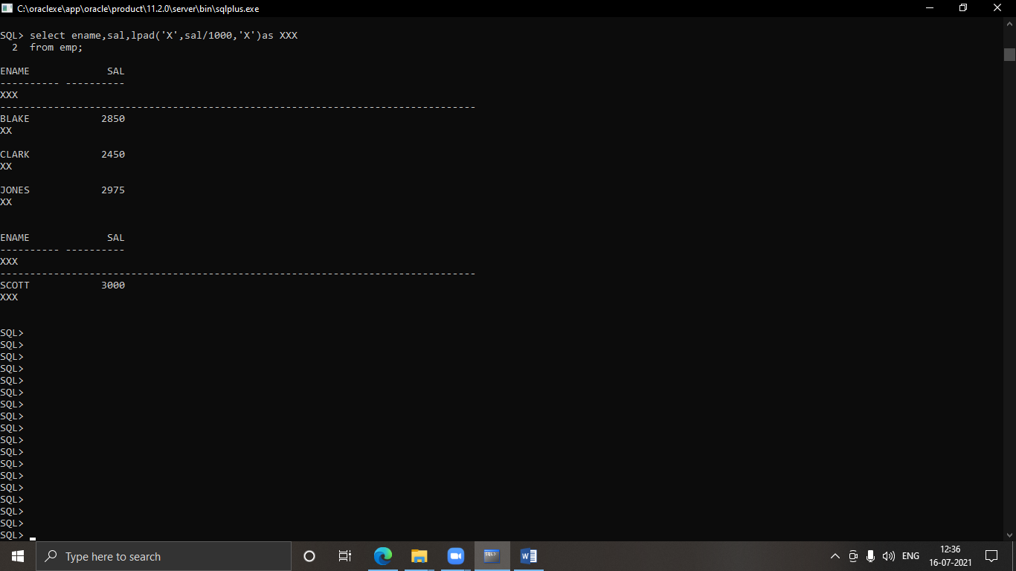

LAB 2

2.1 Single Row Function

1. select student_name,student_dob from student_masters where to_char(student_dob,'Day')!='Saturady' or to_char(student_dob,'Day')!='Sunday' ;

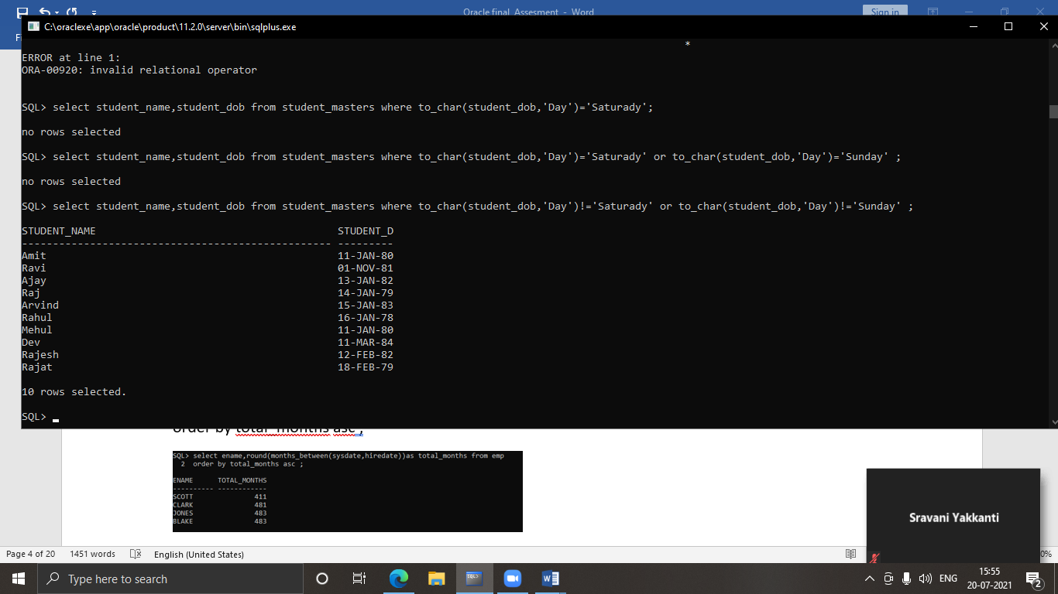

2. select ename,round(months_between(sysdate,hiredate))as total_months from emp

order by total_months asc ;

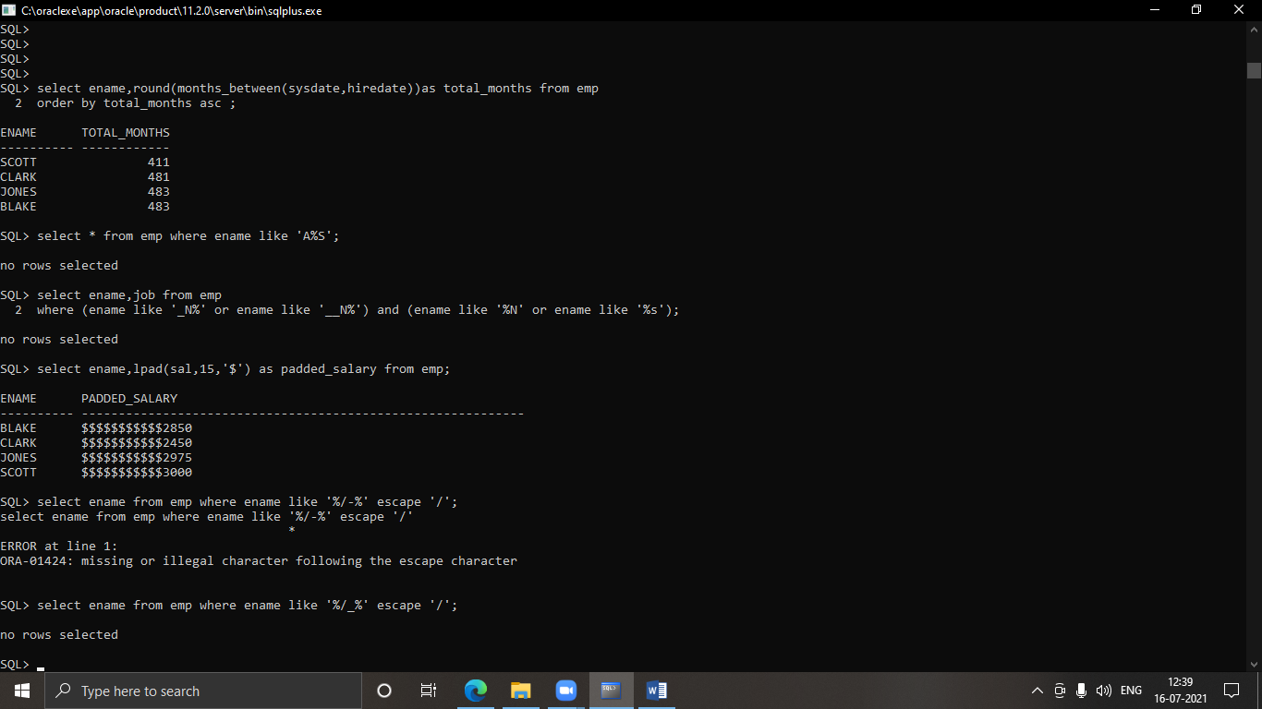

3. select * from emp where ename like 'A%S';



4. select ename,job from emp

where (ename like '_N%' or ename like '__N%') and (ename like '%N' or ename like '%s');



5. select ename,lpad(sal,15,'$') as padded_salary from emp;



6. select ename from emp where ename like '%/_%' escape '/';



7. select * from emp where hiredate like '__-Dec-%';

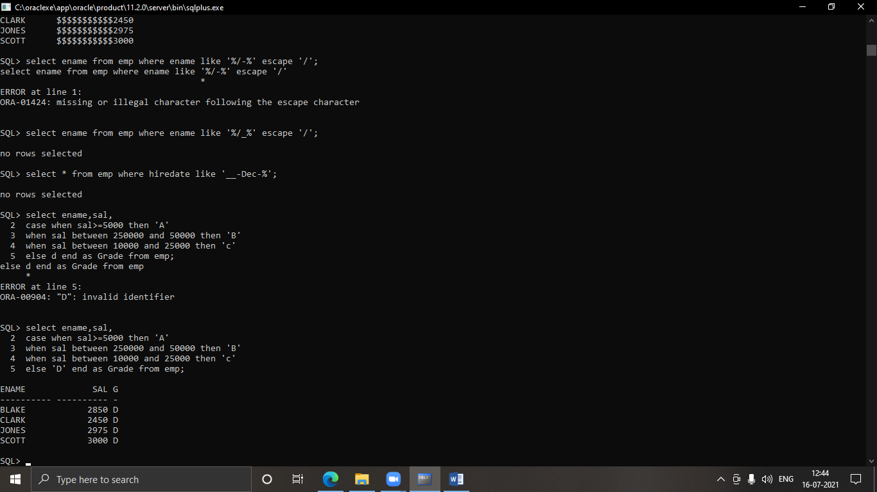

8. select ename,sal,

case when sal>=5000 then 'A'

when sal between 250000 and 50000 then 'B'

when sal between 10000 and 25000 then 'C'

else ‘D’end as Grade from emp;



9. select ename,hiredate,to_char(hiredate,'Day') as day from emp

order by (next_day(hiredate,'MONDAY')-hiredate) desc;

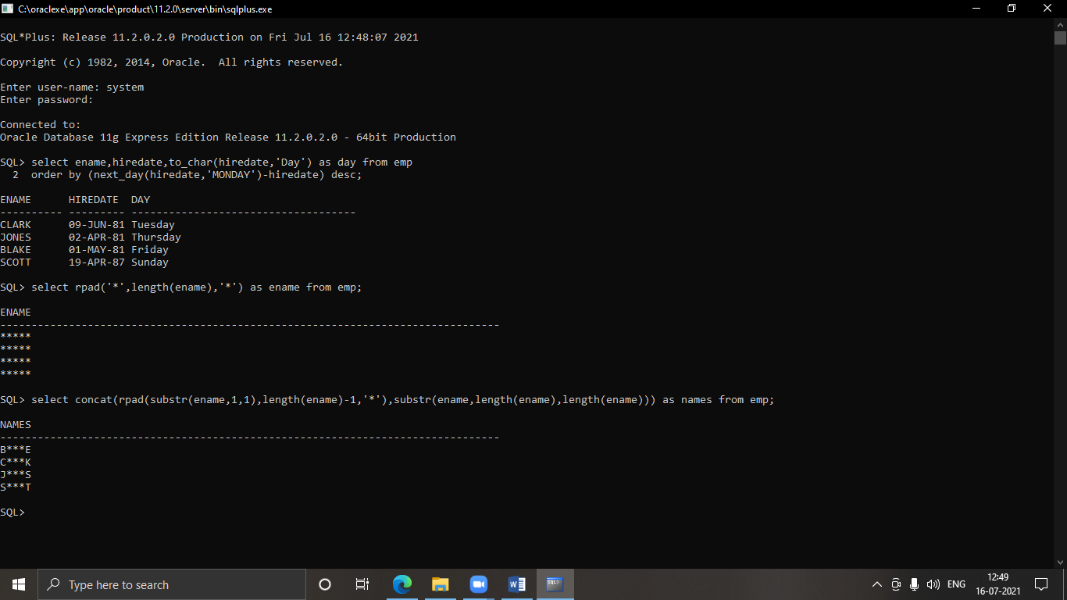

10. select rpad('*',length(ename),'*') as ename from emp;



11. select concat(rpad(substr(ename,1,1),length(ename)-1,'*'),substr(ename,length(ename),length(ename))) as names from emp;



12. select * from emp where to_char(hiredate,'dd')<=15;

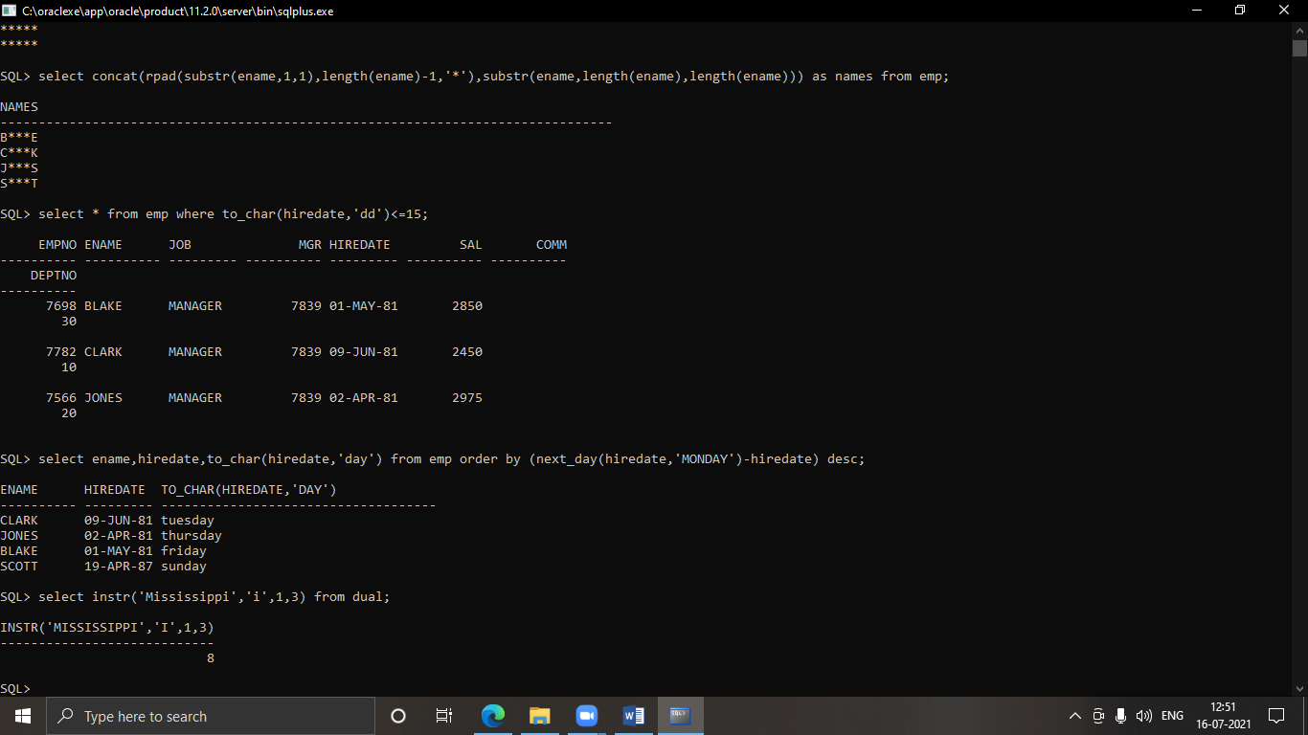

13. select ename,hiredate,to_char(hiredate,'day') from emp order by (next_day(hiredate,'MONDAY')-hiredate) desc;



14. select instr('Mississippi','i',1,3) from dual;



15. select concat(to_char(substr(to_char(next_day(last_day(sysdate)-7,'Friday'),'ddth Month ,YYYY'),1,2),'J'),'Jsp'),SUBSTR(to_char(next_day(last_day(sysdate)-7,'Friday'),3,length(to_char(next_day(last_day(sysdate)-7,'Friday'),'ddth Month,YYYY')))) as datee from dual;

2.2 Group Functions

16. select round( max(sal)) as Maximun,Round(min(sal)) as Minimum,Round(avg(sal)) as Average from emp;

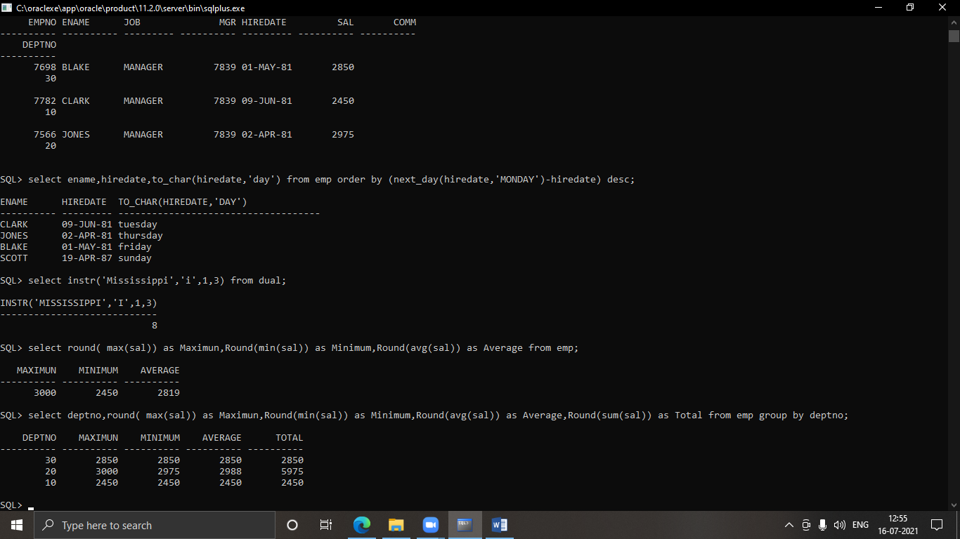

17. select deptno,round( max(sal)) as Maximun,Round(min(sal)) as Minimum,Round(avg(sal)) as Average,Round(sum(sal)) as Total from emp group by deptno;

  
18. select sm.dept_code,dm.dept_name,count(sm.staff_name) from staff_masters sm JOIN department_masters dm on sm.dept_code = dm.dept_code group by sm.dept_code,dm.dept_name;

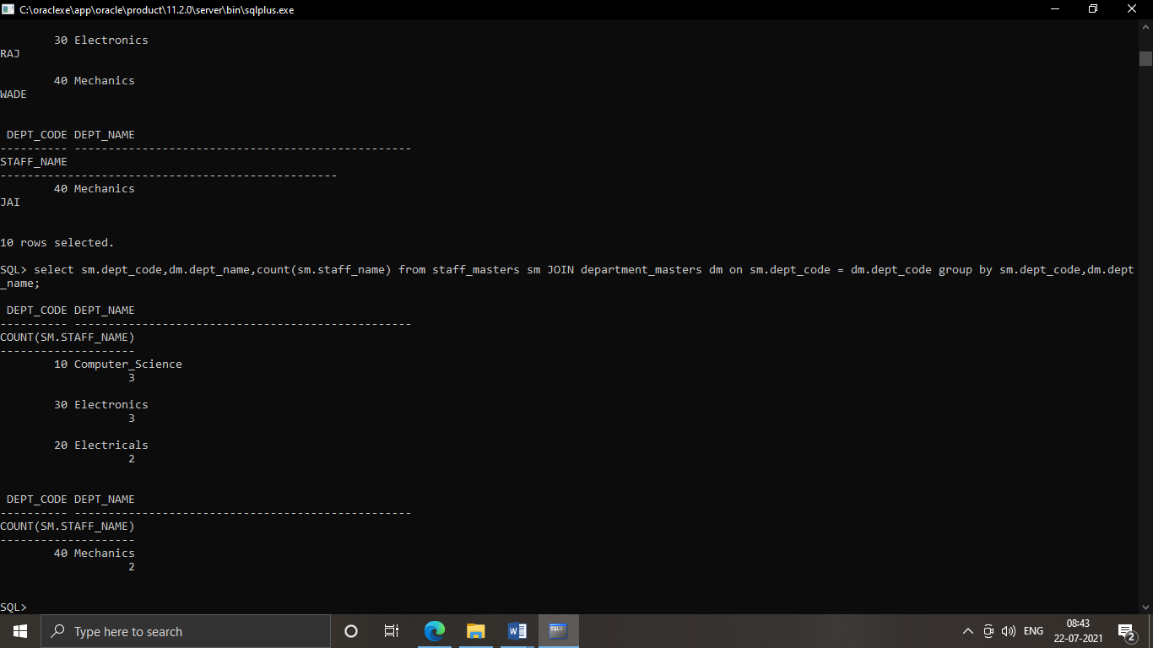

19. select count(mgr) as Total_mgr from emp where mgr is not null group by mgr;

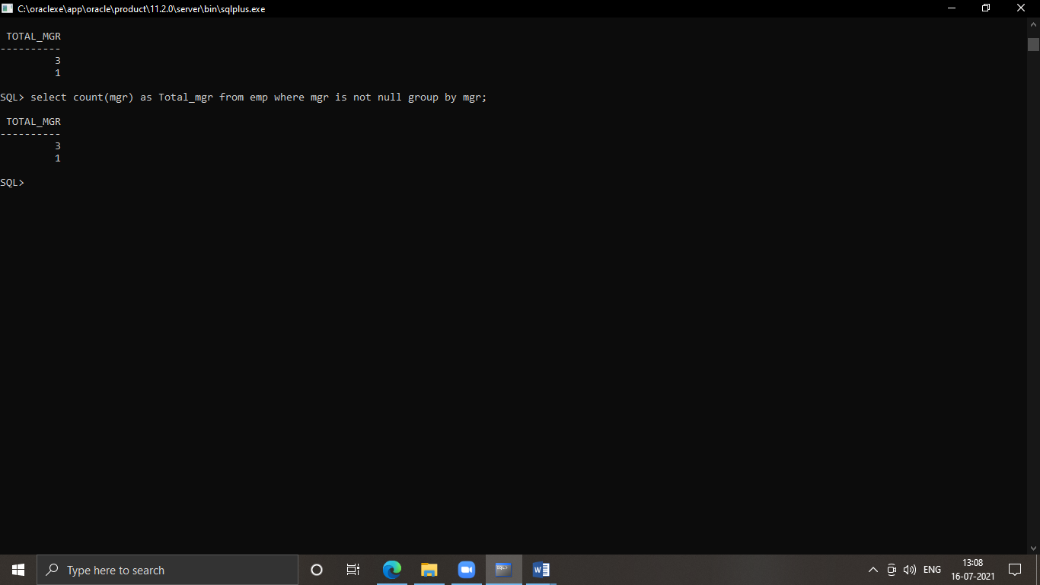

20. create view min_sall as select mgr_code,min(staff_sal) as min_salary from staff_masters where mgr_code is not null group by mgr_code;

select mis.mgr_code,staff.staff_name,mis.min_salary from min_sal mis JOIN staff_masters staff on mis.mgr_code=staff.staff_code where mis.min_salary>10000 order by min_salary DESC;

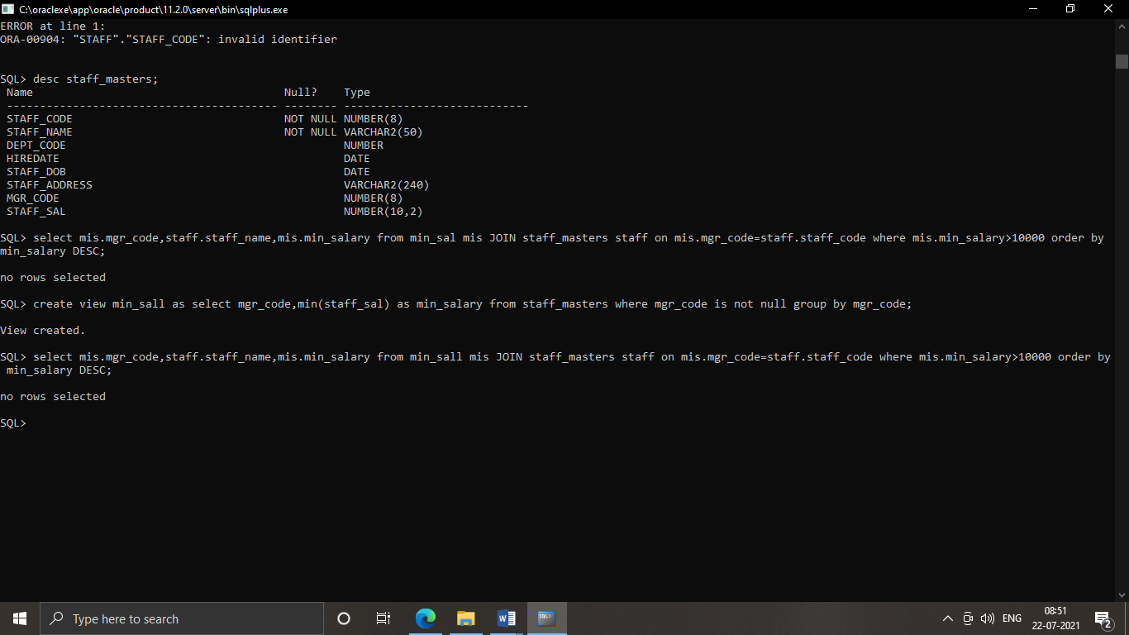

LAB 3: JOINS AND SUB QUERIES

3.1 Joins and Sub Queries

1. select staff_name,staff_code,staff_sal from staff_masters,department_masters where staff_masters.staff_code=department_masters.dept_code and staff_sal>20000;

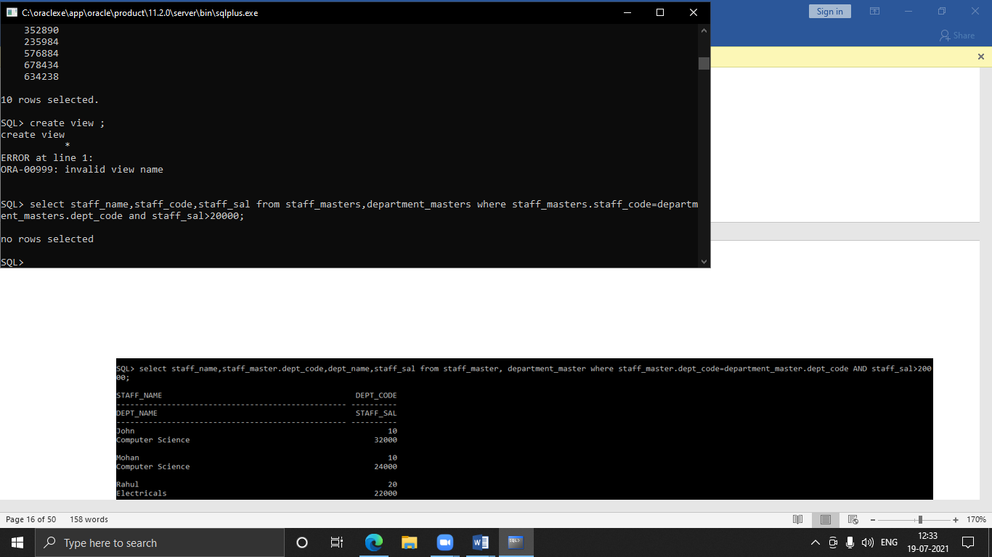

1. select staff_name,staff_code,dept_name,staff_sal from staff_masters,department_masters where staff_masters.staff_code=department_masters.dept_code and staff_code = 10 and staff_name like '%a%';

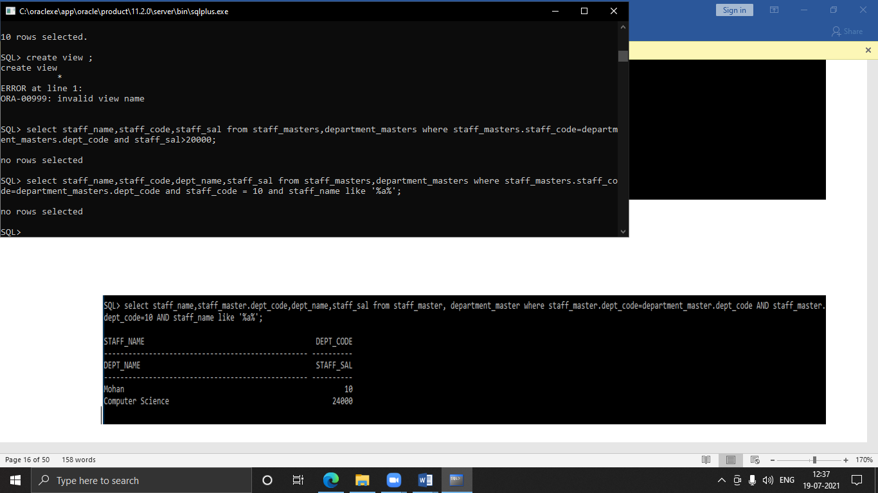

1. select staff_code as staff#, staff_name as staff, dept_name,mgr_code as mgr# from staff_masters sm,department_masters dm where sm.dept_code=dm.dept_code;

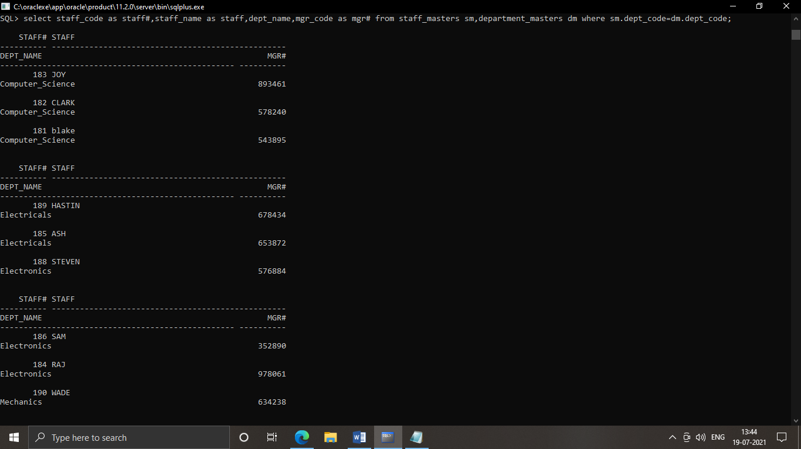

1. select sm.student_code,sm.student_name,smm.sub1,smm.sub2,smm.sub3

from student_masters sm,student_marks smm

where sm.student_code=smm.student_code and sm.dept_code IN(10,20)and

smm.sub1>=60 and smm.sub2>=60 and smm.sub3>=60;

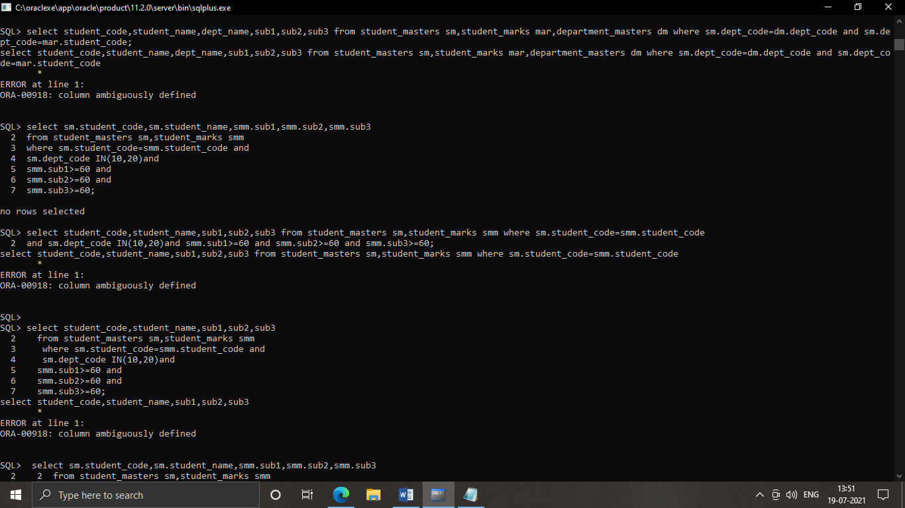

1. select stu.student_code,stu.student_name,bm.book_code,bm.book_name from student_masters stu,book_masters bm,book_transcations bt

where bt.student_code=stu.student_code and bt.book_code=bm.book_code and bt.book_expected_return_date in (sysdate);

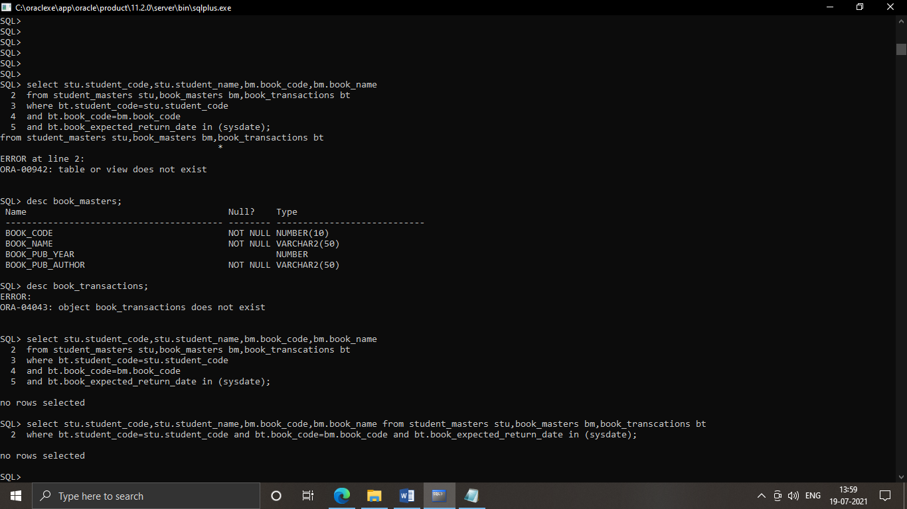

1. SELECT s.staff_code, s.staff_name, dp.dept_name, dg.design_code, bt.book_code,bm.book_name, bt.book_issue_date

FROM staff_masters s,department_masters dp, designation_master dg,book_masters bm,book_transcations bt

where bt.book_code=bm.book_code and bt.staff_code=s.staff_code and s.staff_code=dg.design_code and s.dept_code=dp.dept_code and (sysdate-book_issue_date)<30;

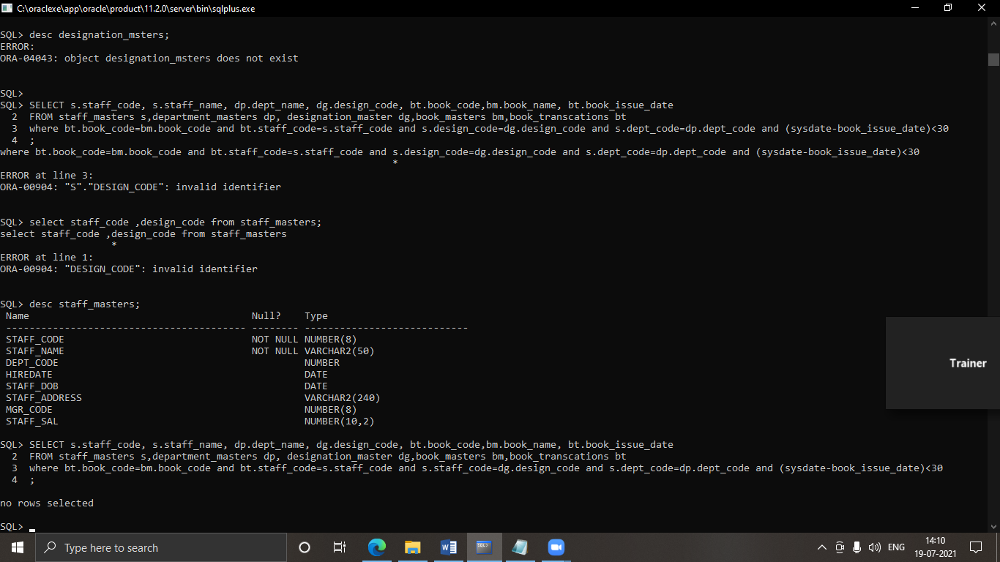

1. select s.staff_code,s.staff_name,des.design_name,dep.dept_name from staff_masters s,designation_master des,department_masters dep where s.staff_code=des.design_code and des.design_name NOT IN ('HOD');

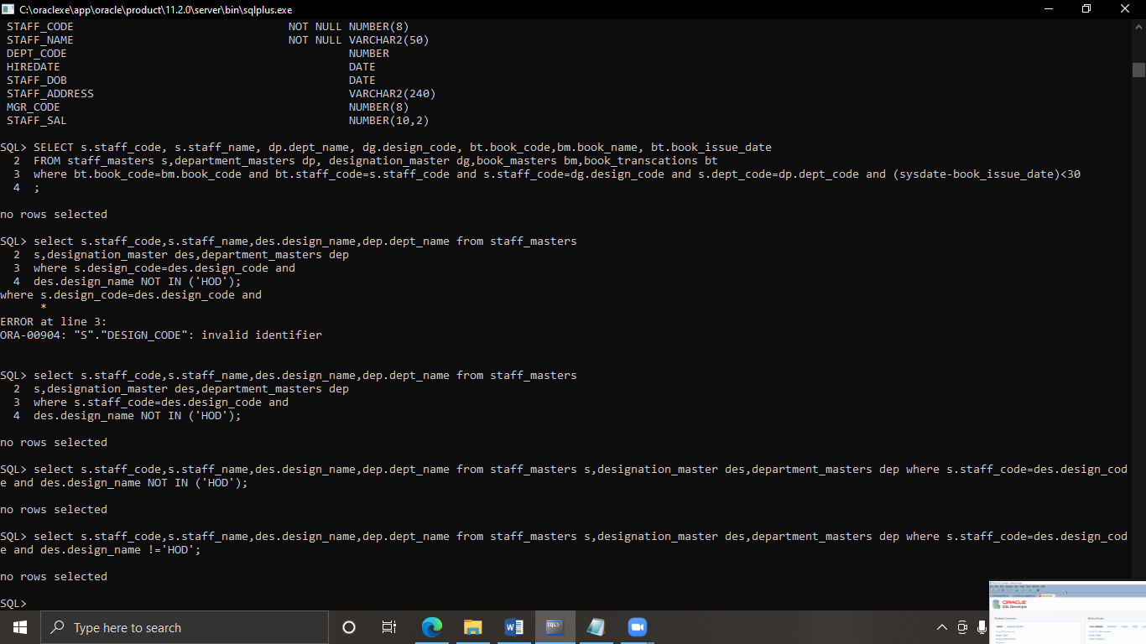

1. select s.student_code,s.student_name,d.dept_name,m.sub1+m.sub2+m.sub3 as Total_Marks

from student_masters s,department_masters d,student_marks m

where s.dept_code=d.dept_code and s.student_code=m.student_code

order by d.dept_name,total_marks;

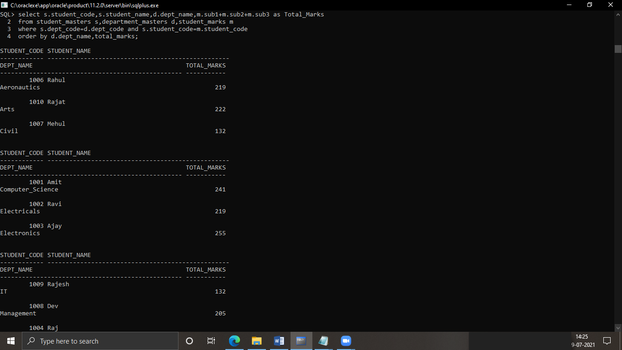

1. select s.staff_code,s.staff_name,d.design_name, dm.dept_name, bt.book_code,

bm.book_name,5*(sysdate-bt.book_expected_return_date) as fine

FROM staff_masters s,Designation_Master d, book_masters bm, book_transcations

bt,department_masters dm

WHERE s.staff_code=d.design_code

AND s.staff_code=dm.dept_code

AND bt.staff_code=s.staff_code

AND bt.book_code=bm.book_code;

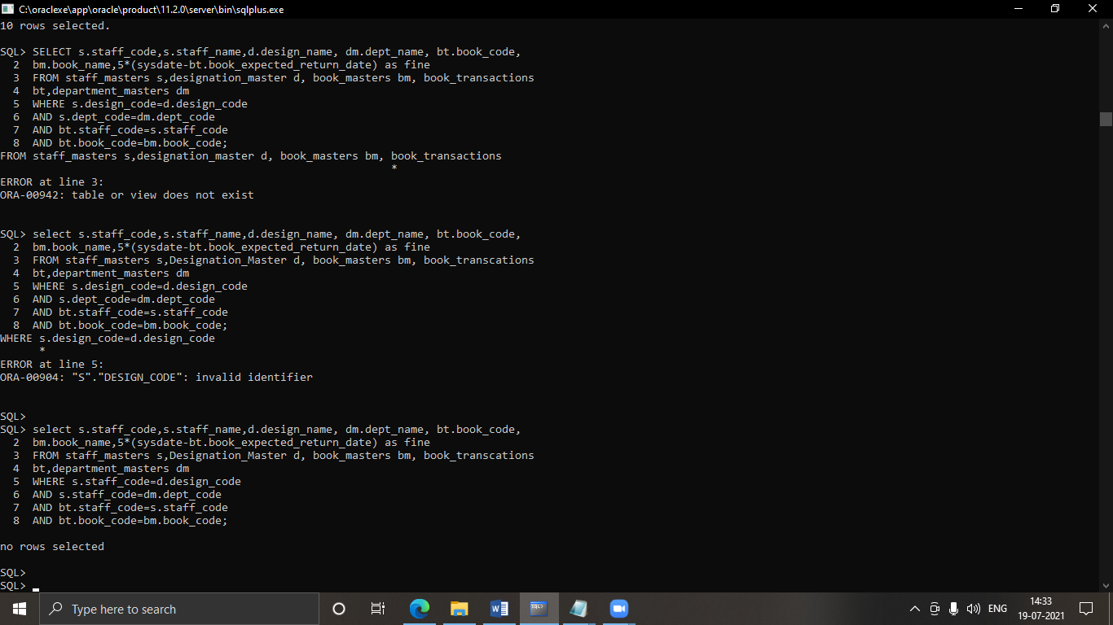

1. select staff_name,staff_code,staff_sal from staff_masters where staff_sal<=(select avg(staff_Sal) from staff_masters);

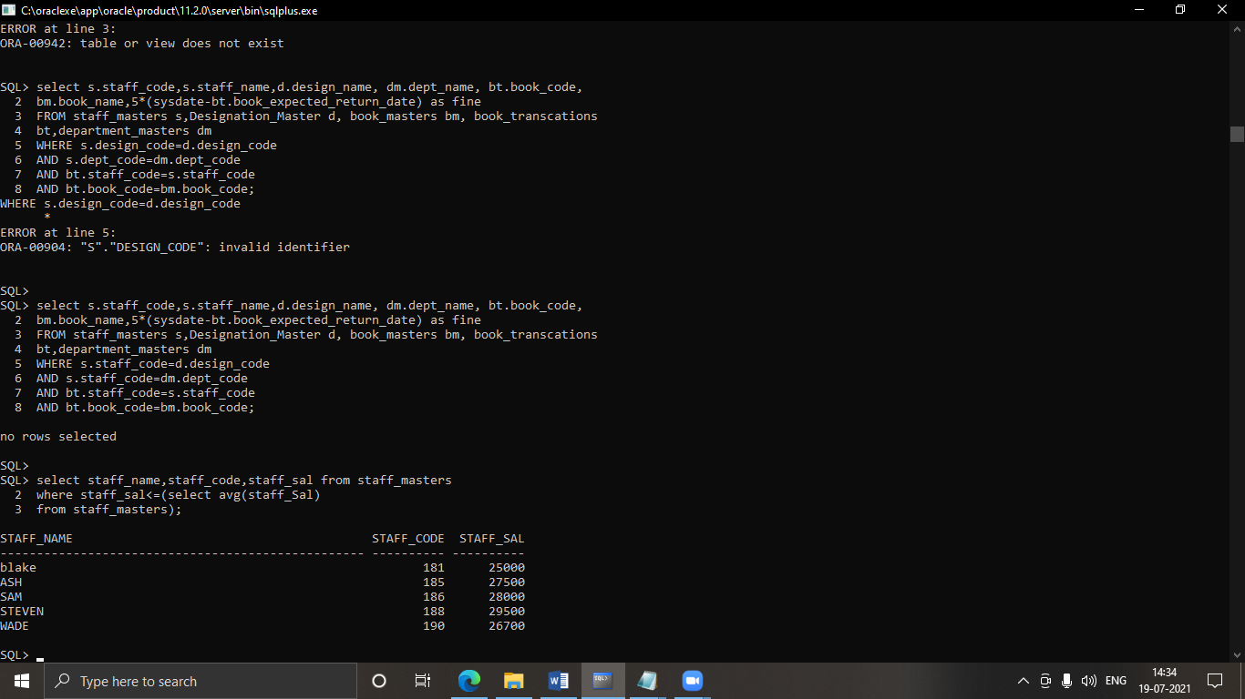

1. select staff_code,staff_name from staff_masters where mgr_code IS NULL;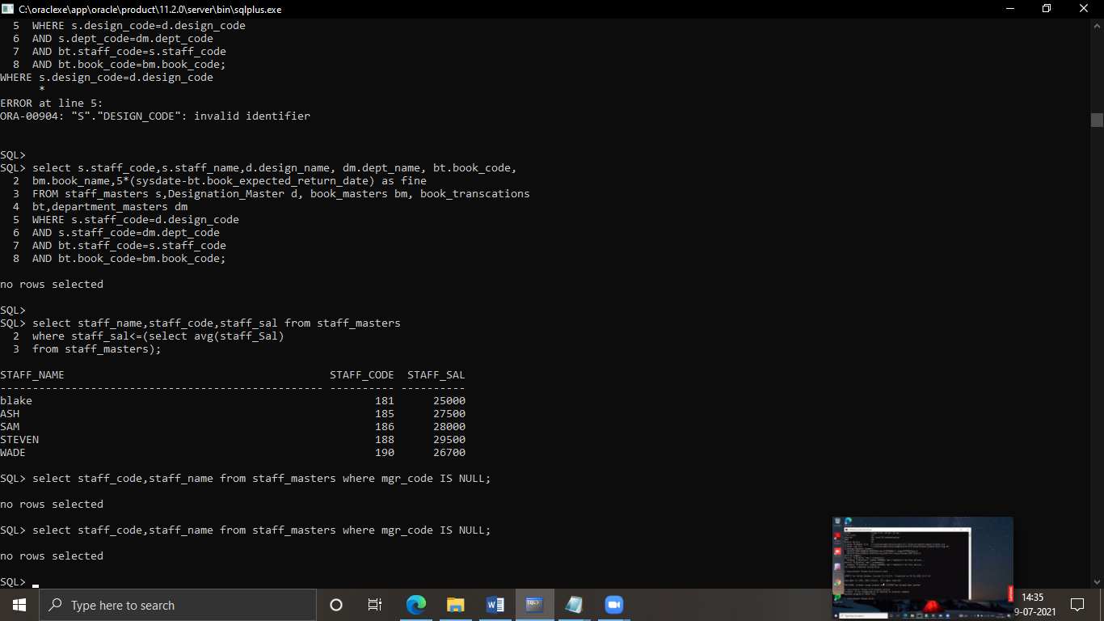
2. create view count AS SELECT book_pub_author,count(*) AS COUNT from book_masters GROUP BY book_pub_author;

select b.book_name,b.book_pub_author from book_masters b,count c where b.book_pub_author=c.book_pub_author and c.count>1;

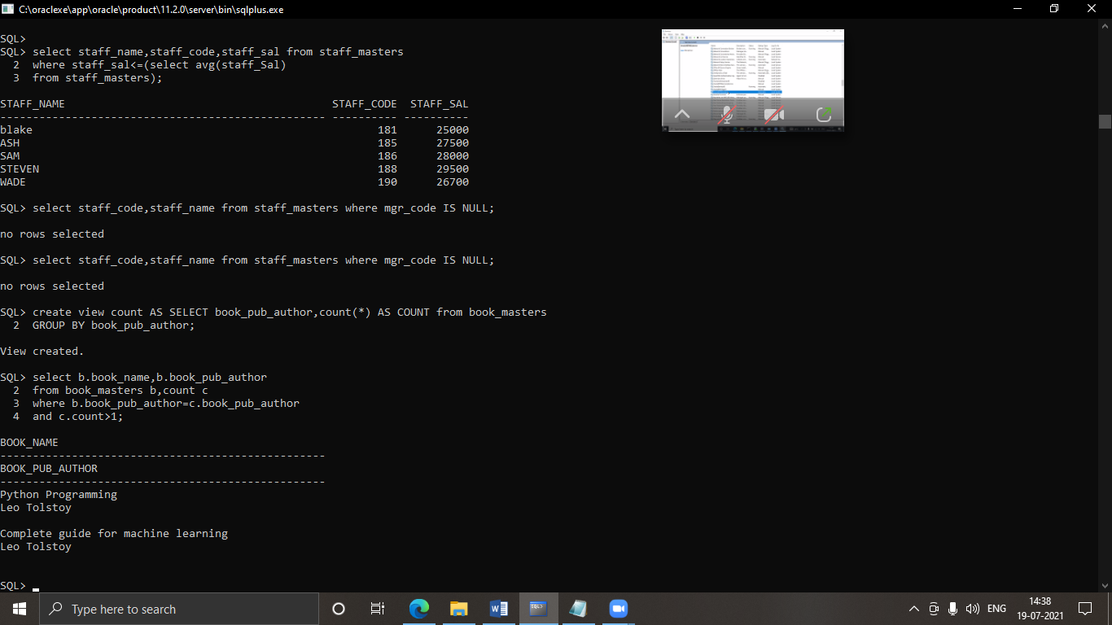

1. select s.staff_code , s.staff_name , d.dept_name

from staff_masters s , department_masters d

where (s.staff_code in (select b.staff_code from book_transcations b

where s.staff_code=b.staff_code

group by staff_code

having count(b.staff_code)>1));

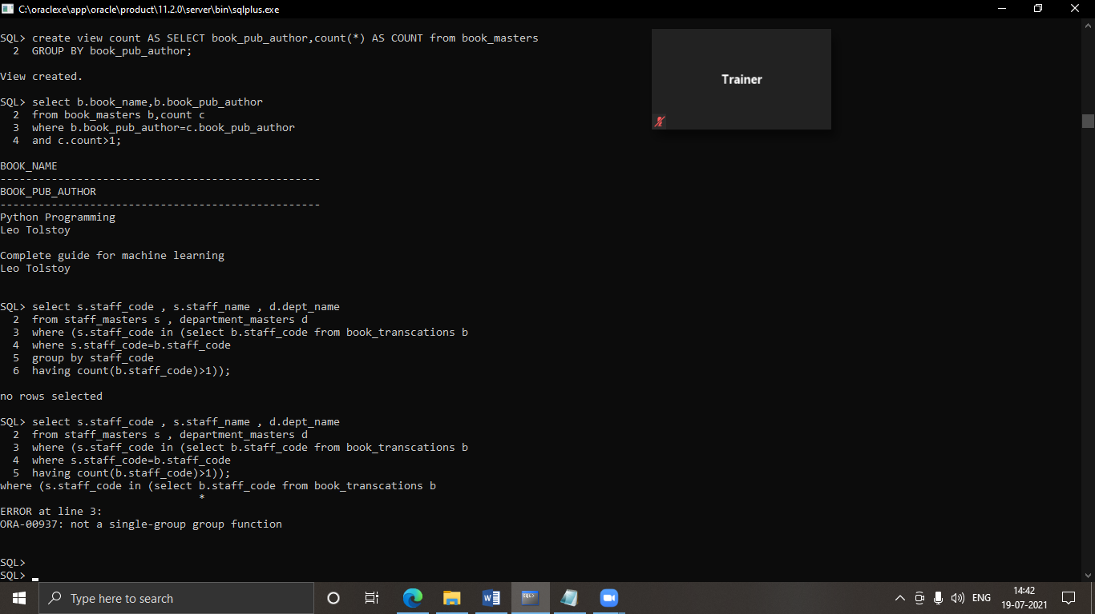

1. SELECT DISTINCT s.student_code,s.student_name,d.dept_name,sm.sub1,sm.sub2,

sm.sub3,sm.sub1+sm.sub2+sm.sub3 AS total

FROM student_masters s,department_masters d,student_marks sm

WHERE s.dept_code=d.dept_code

AND s.student_code=sm.student_code

AND rownum<=10

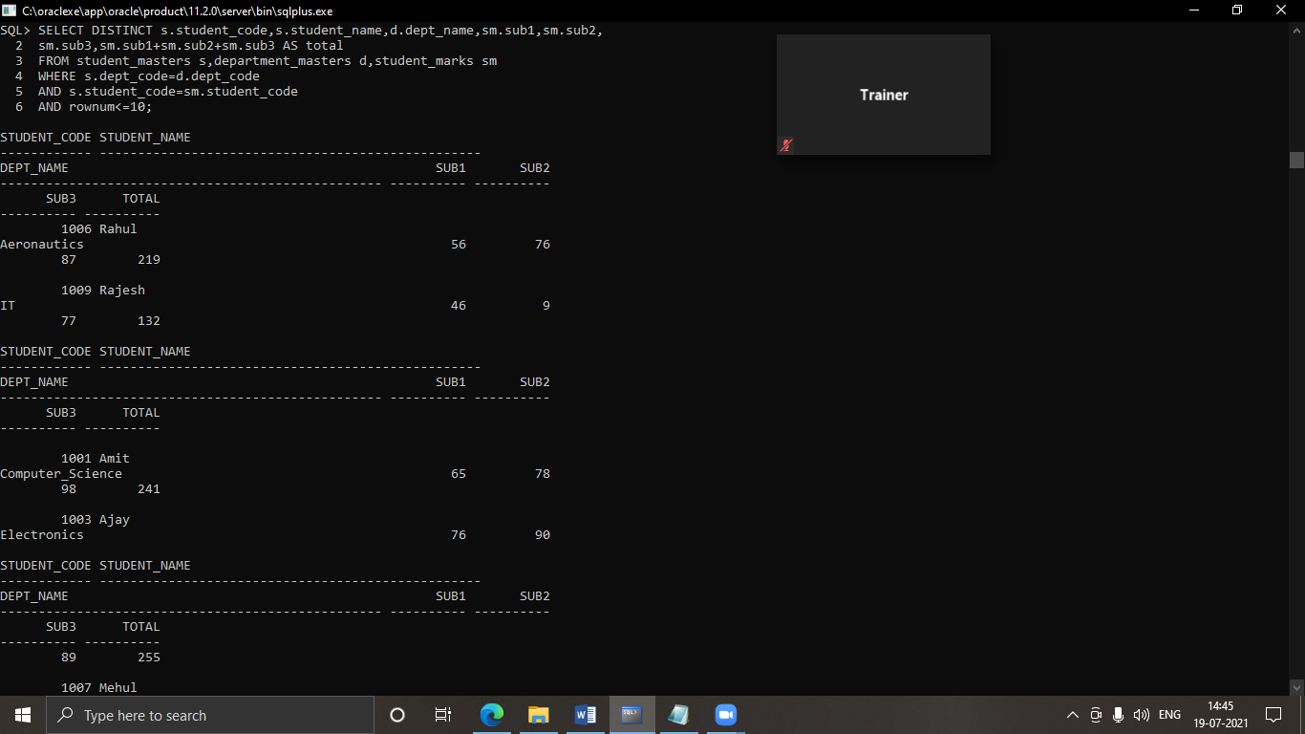

1. select s.staff_name,d.dept_name,s.staff_sal

from staff_masters s,department_masters d

where s.dept_code=d.dept_code

AND s.staff_sal<(Select avg(m.staff_sal)

FROM staff_masters m

WHERE s.dept_code=m.dept_code);

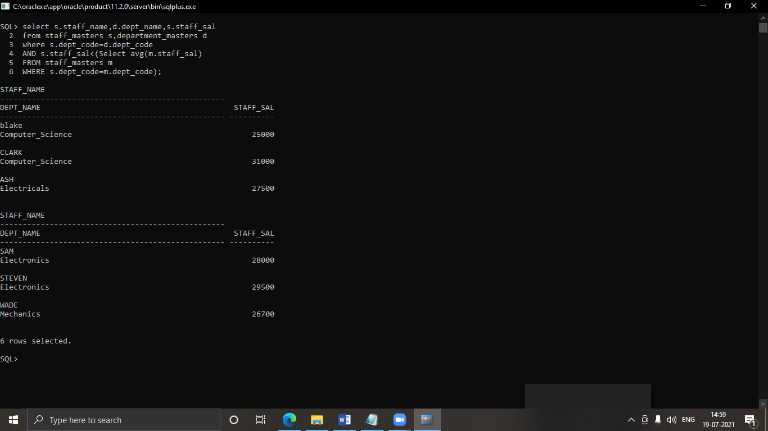

1. select s.staff_name,d.dept_name from staff_masters s,department_masters d where s.dept_code=d.dept_code;

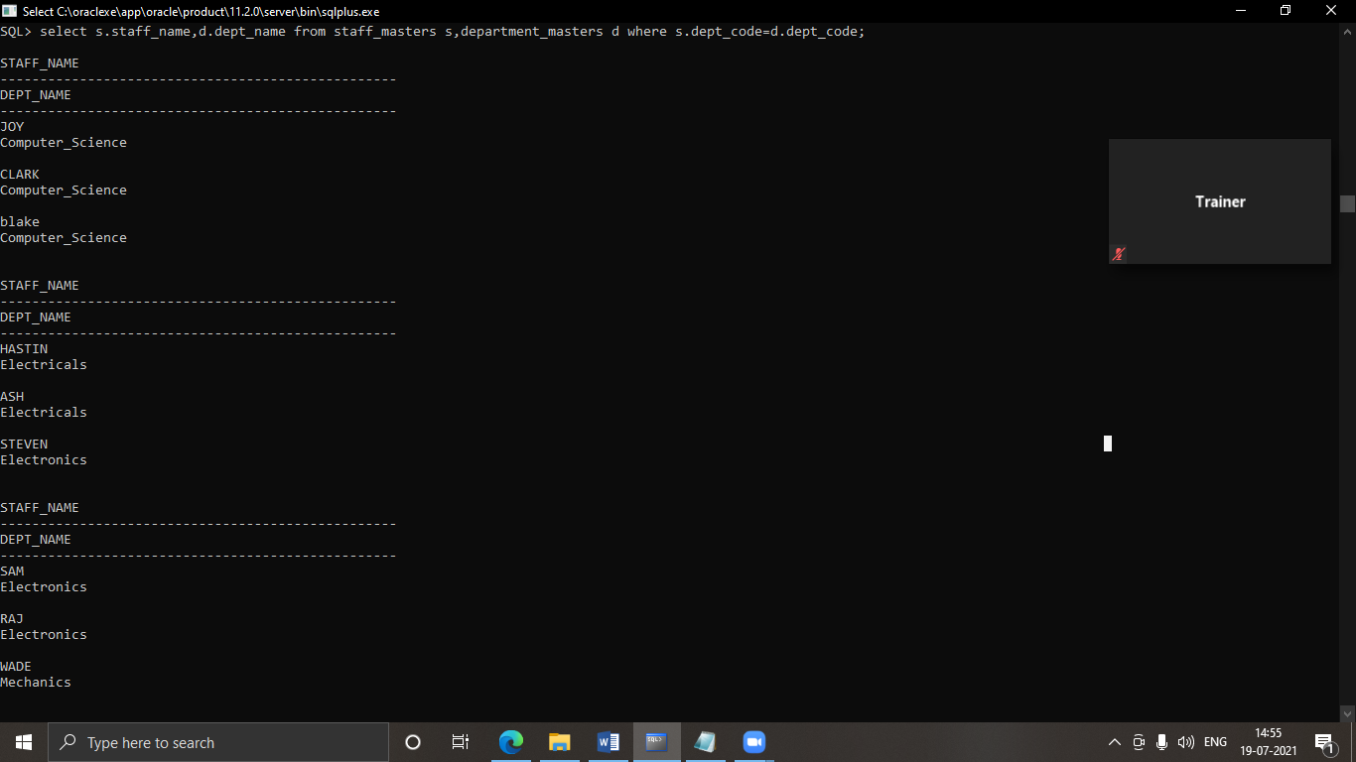

1. SELECT s.student_code, sm. student_name FROM student_marks s, student_masters sm,

department_masters d

WHERE s.student_code=sm.student_code

AND sm.dept_code=d.dept_code

AND d.dept_name='Computer_Science'

AND rownum<2

ORDER BY sub1, sub2, sub3;

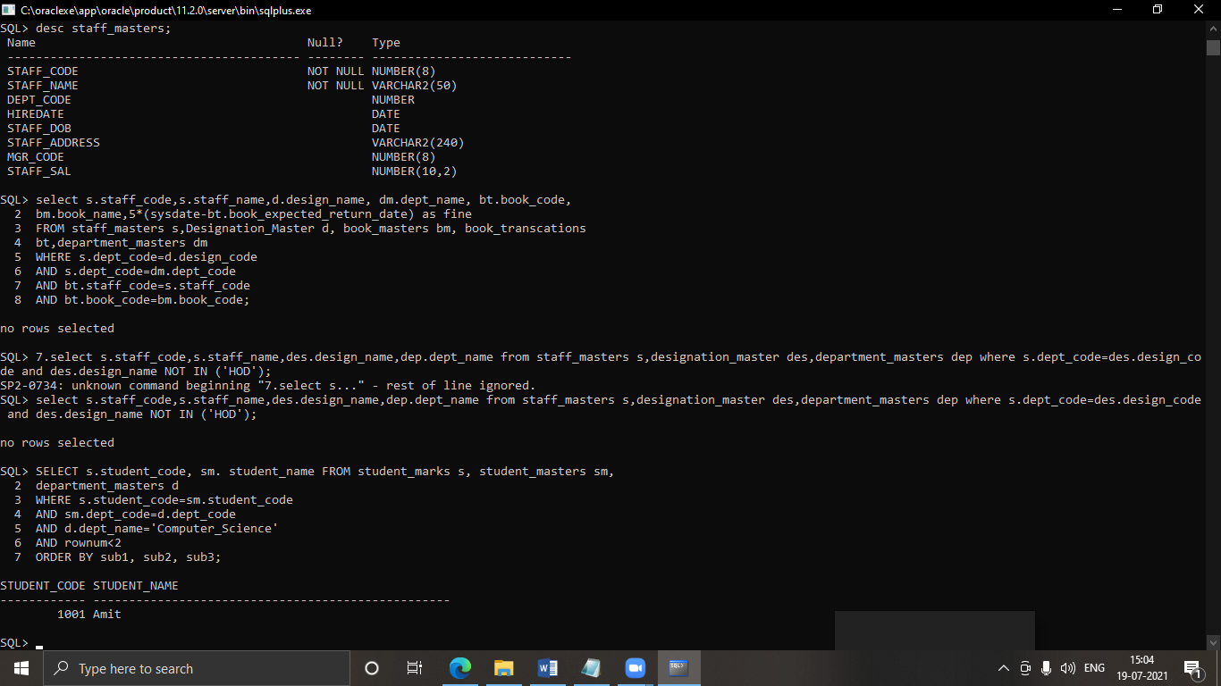

1. create view countmax AS SELECT dept_code,count(student_name) AS count FROM student_masters GROUP BY dept_code;

SELECT s.student_code, sm. student_name,d.dept_name FROM student_marks s, student_masters sm, department_masters d, countmax c WHERE s.student_code=sm.student_code AND sm.dept_code=d.dept_code AND c.dept_code=sm.dept_code AND c.count=(SELECT MAX(count) FROM countmax);

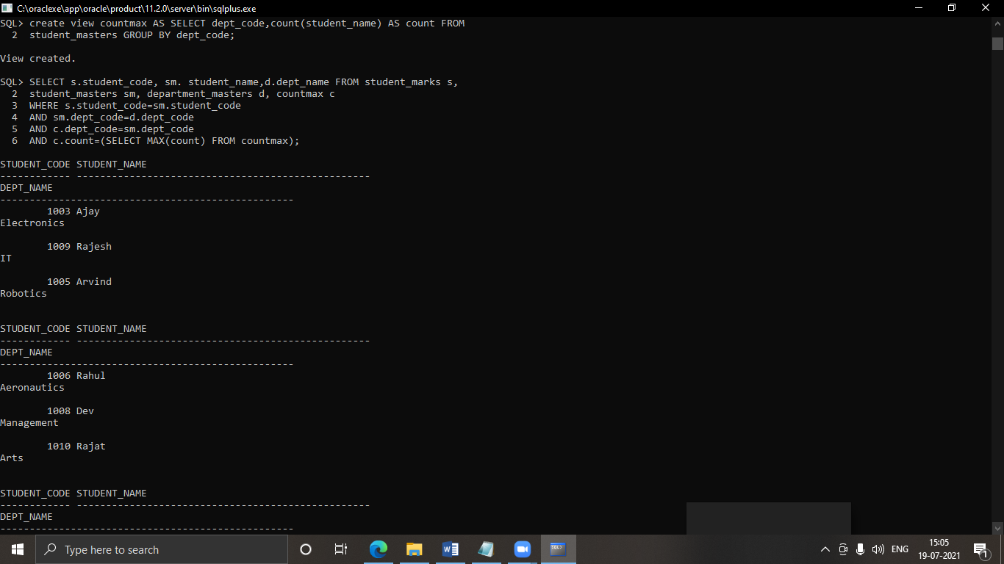

1. SELECT s.staff_code,s.staff_name,d.dept_name, dm.design_name FROM staff_masters s,department_masters d, designation_master dm

WHERE s.dept_code=d.dept_code AND s.staff_code=dm.design_code

ORDER BY hiredate desc;

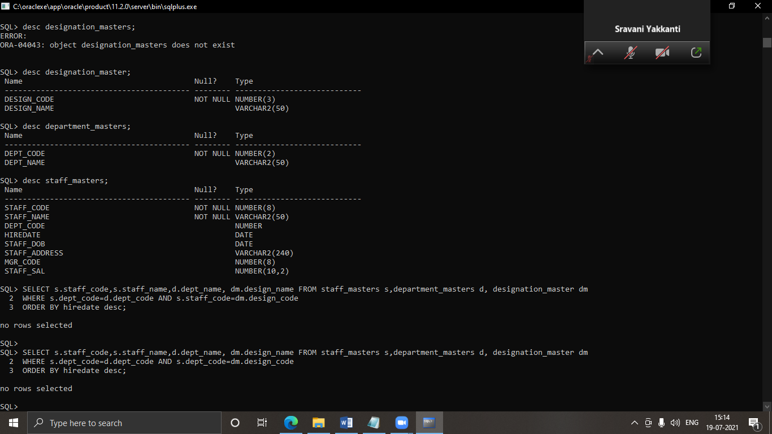

1. create view ms as select mgr_code ,count(staff_name) as strength from staff_masters where mgr_code is not null group by mgr_code;

select staff_name,strength from staff_masters,ms where staff_masters.mgr_code=ms.mgr_code;

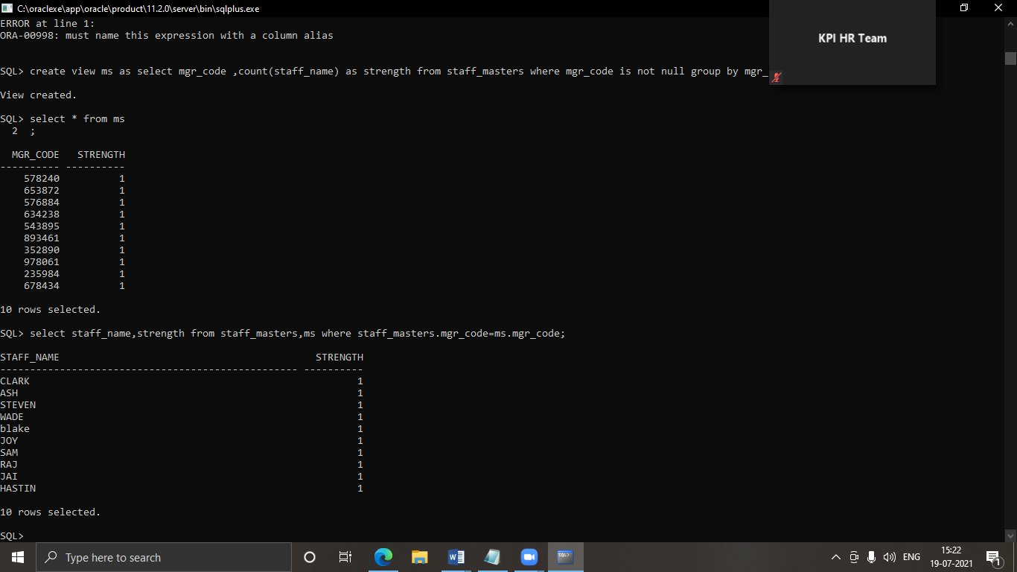

3.2 Set Operators

1. select * from previous_products UNION select * from current_products;

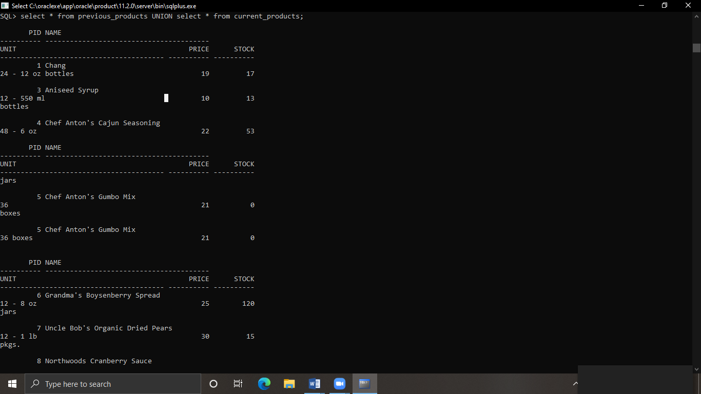

2. select * from previous_products UNION ALL select * from current_products;

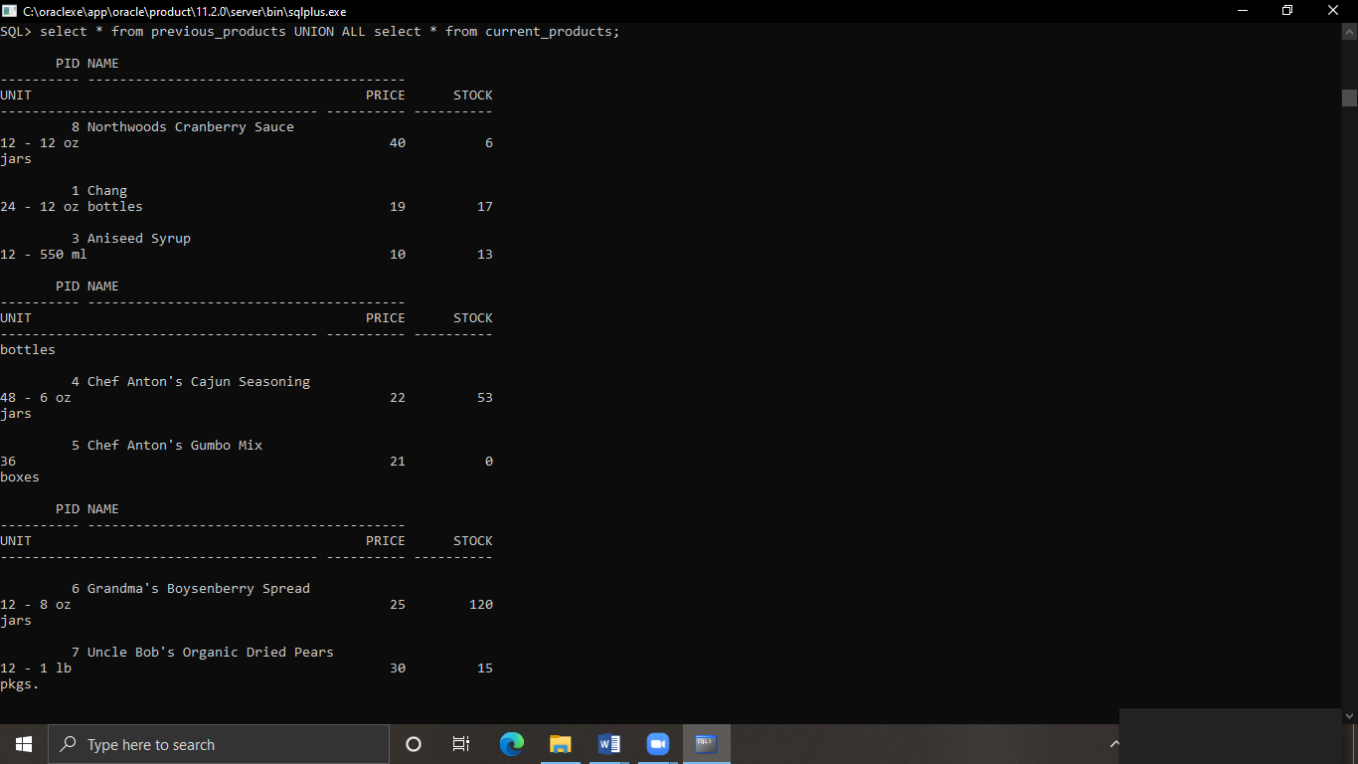

3. select * from previous_products INTERSECT select * from current_products;

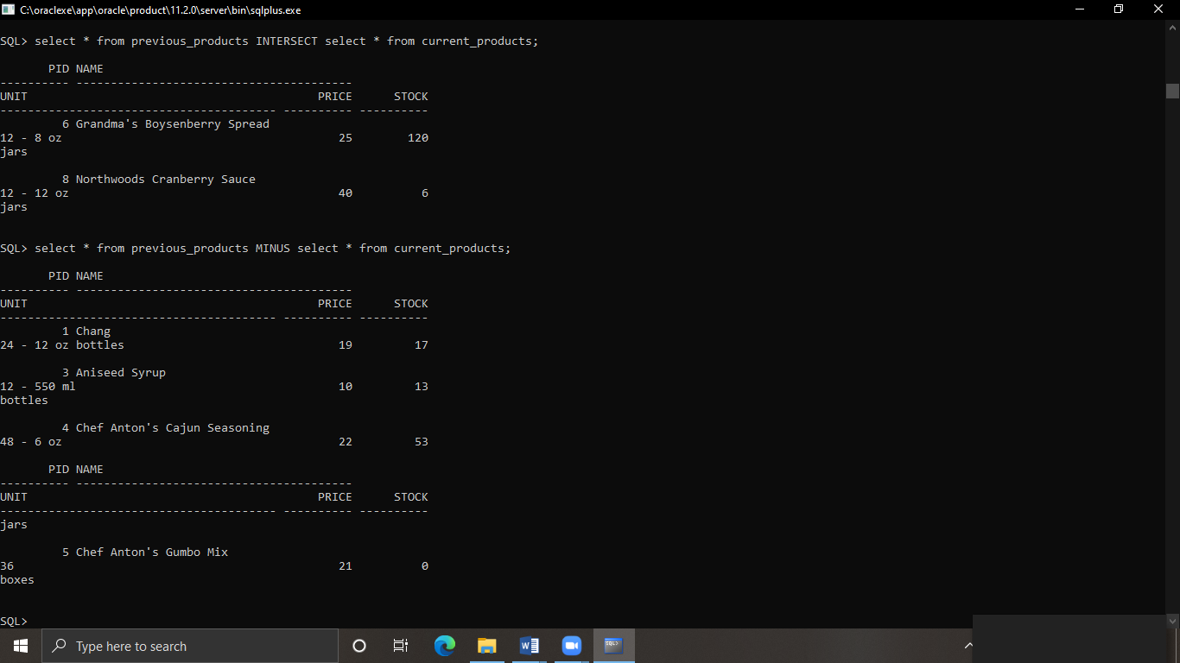

4. select * from previous_products MINUS select * from current_products;



LAB4 : DATA BASE OBJECTS

1. create table cust_tab(custid number(5),custname number(20),add1 varchar2(30),add2 varchar2(30));

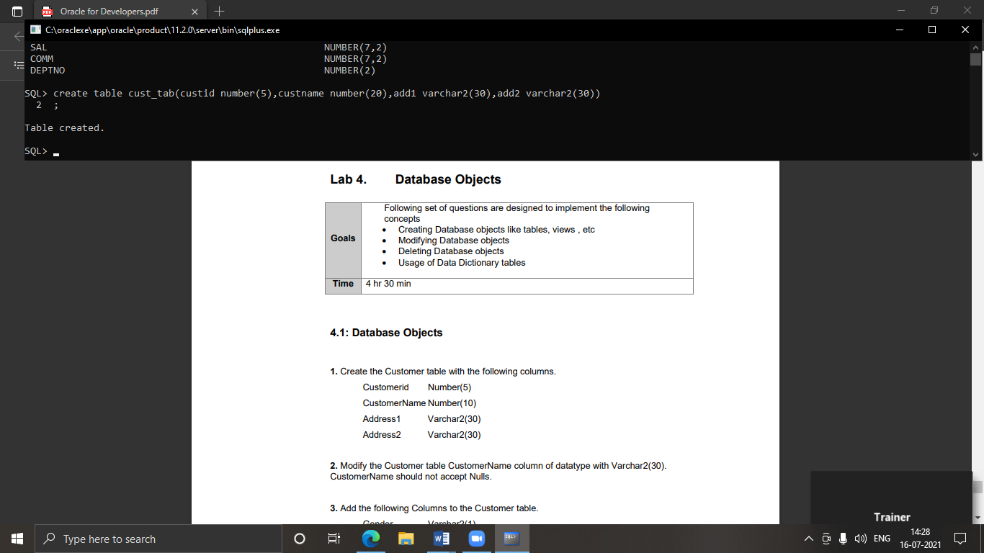

1. alter table cust_tab modify(custname varchar2(30) not null);

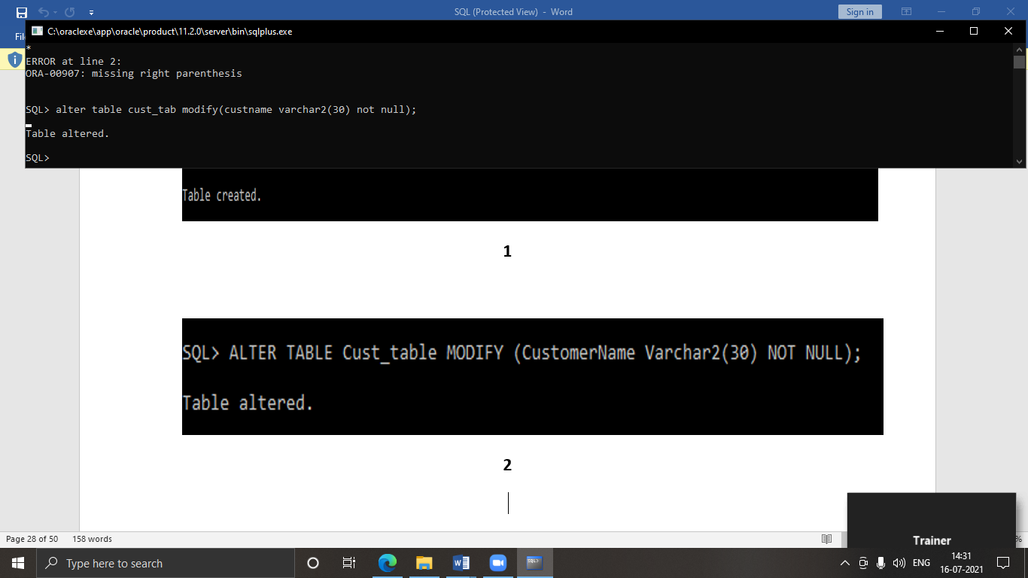

1. alter table cust_tab add(gender varchar2(1),age number(3),phoneno number(10));

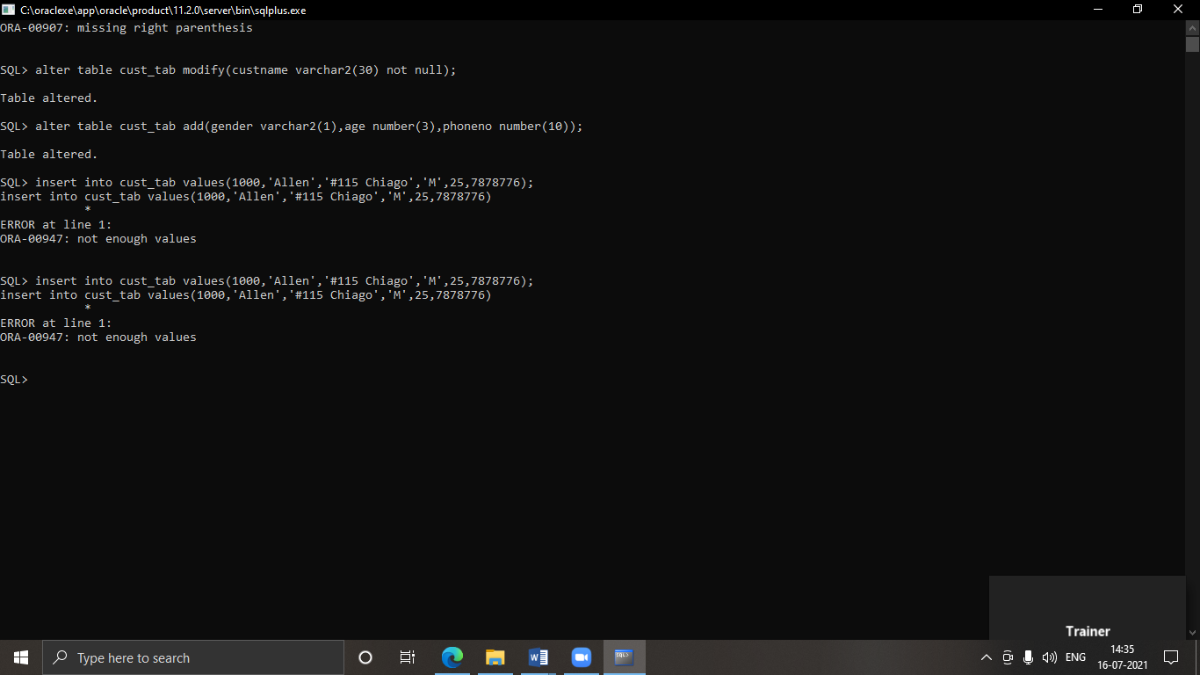

1. insert into cust_tab values(1000,'Allen','#115 Chiago','#115 Chiago','M',25,7878776);

insert into cust_tab values(1001,'George','#115 France','#115 France','M',25,434524);

insert into cust_tab values(1002,'Becker','#115 New York','#115 New York','M',45,431525);

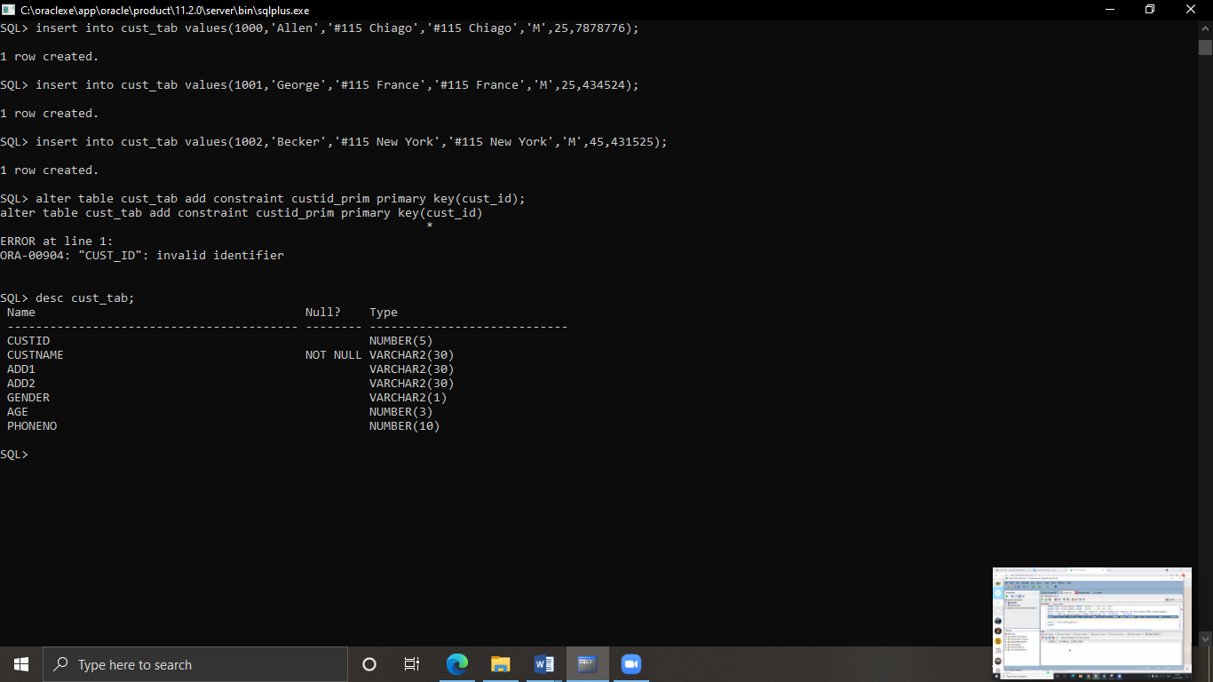

1. alter table cust_tab add constraint custidd_prim PRIMARY KEY(custid);

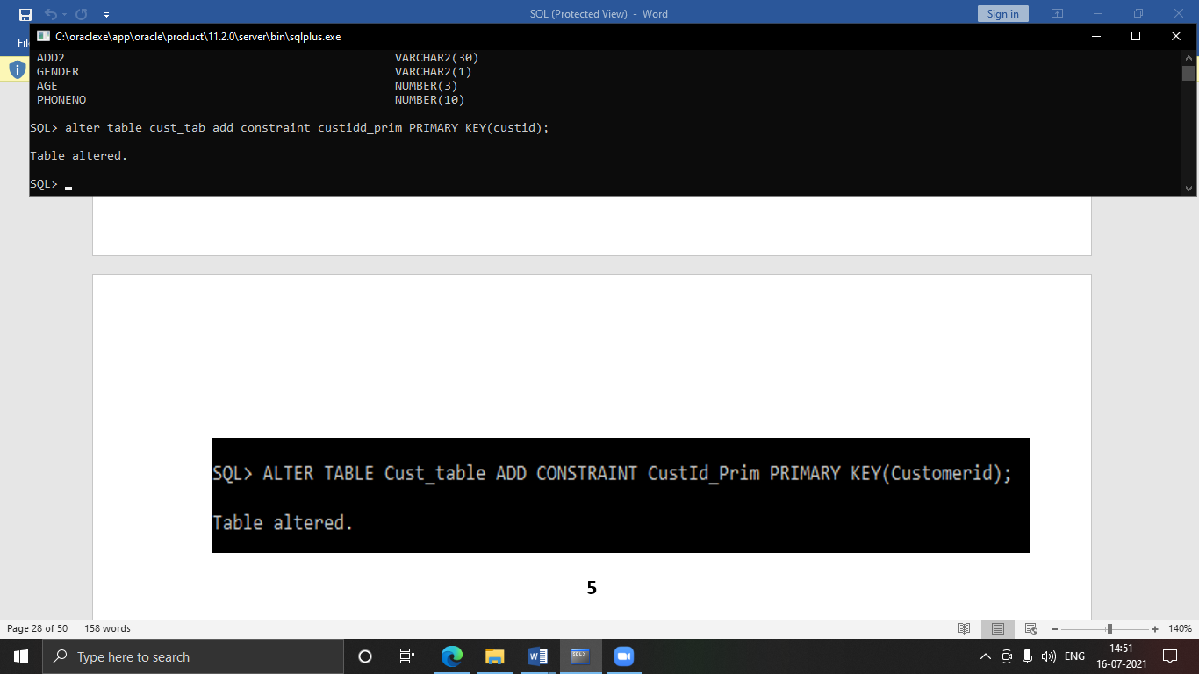

1. insert into cust_tab values(1002,'John','#114 Chicago','#114 Chicago','M',45,439525);

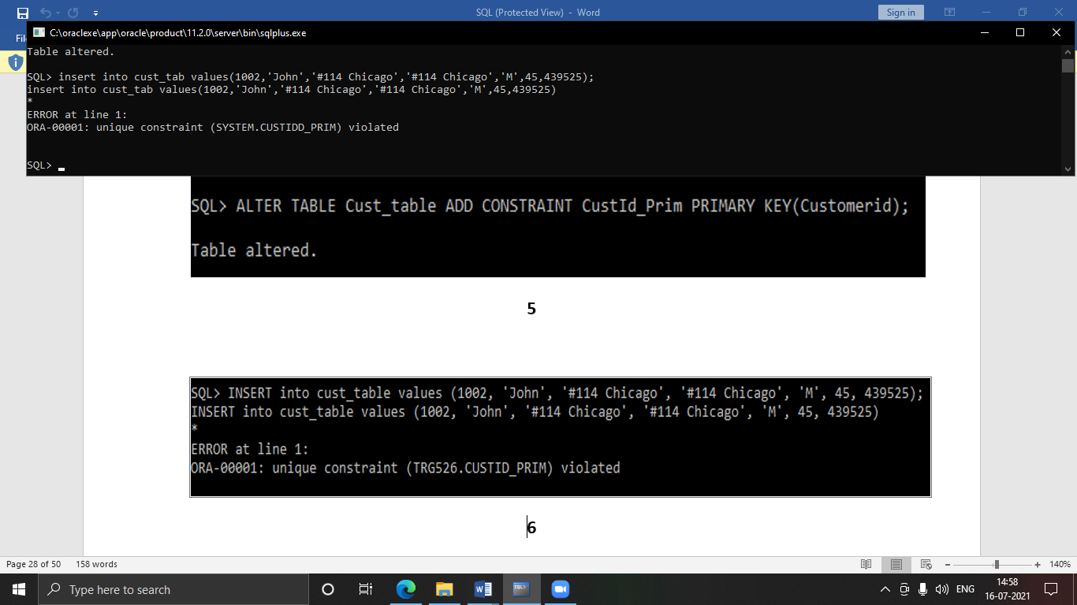

1. alter table cust_tab drop constraint custidd_prim;

insert into cust_tab values(1002,'Becker','#114 New York','#114 New York','M',45,431525);

insert into cust_tab values(1002,'Nanapatekar','#115 India','#115 India','M',45,431525);

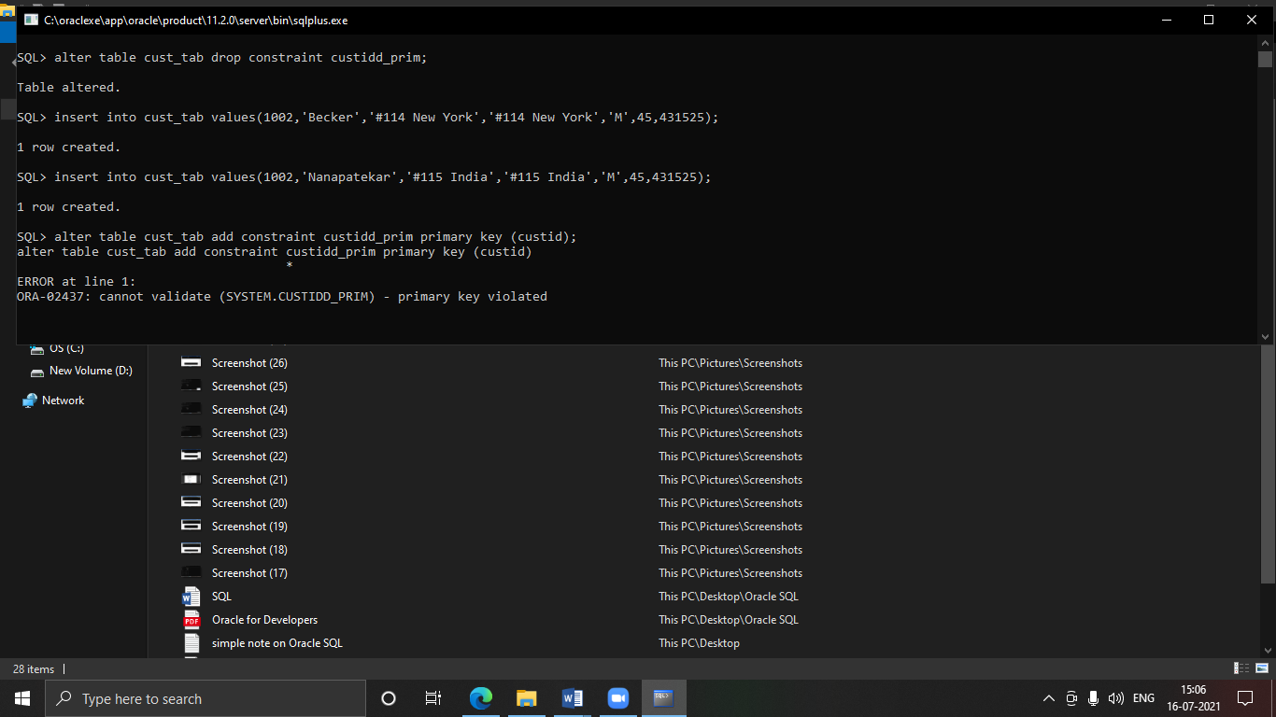

1. alter table cust_tab add constraint custidd_prim primary key (custid);



1. alter table cust_tab add(amount number(10));

insert into cust_tab values(1002,'Becker','#114 New York','#114 New York','M',45,431525,15000.50);

insert into cust_tab values(1003,'Nanapatekar','#115 India','#115 India','M',45,431525,20000.50);

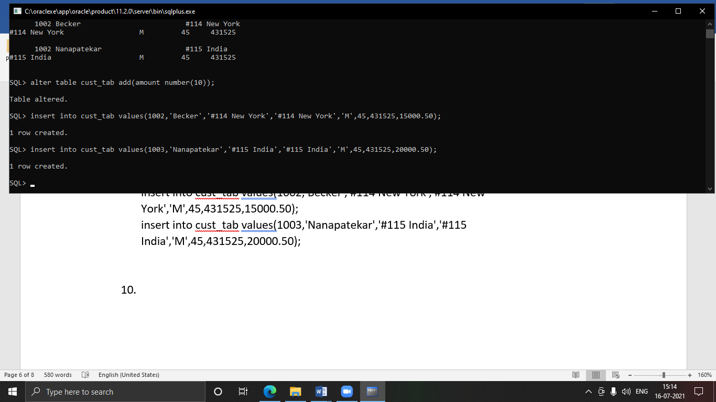

1. truncate table cust_tab;

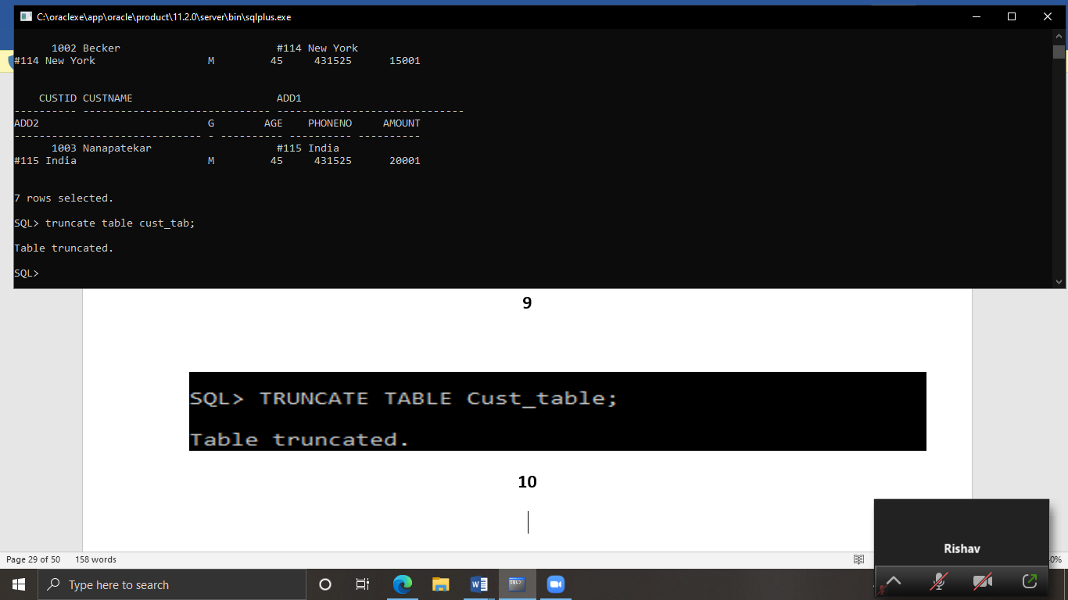

1. alter table cust_tab add(email varchar2(50));

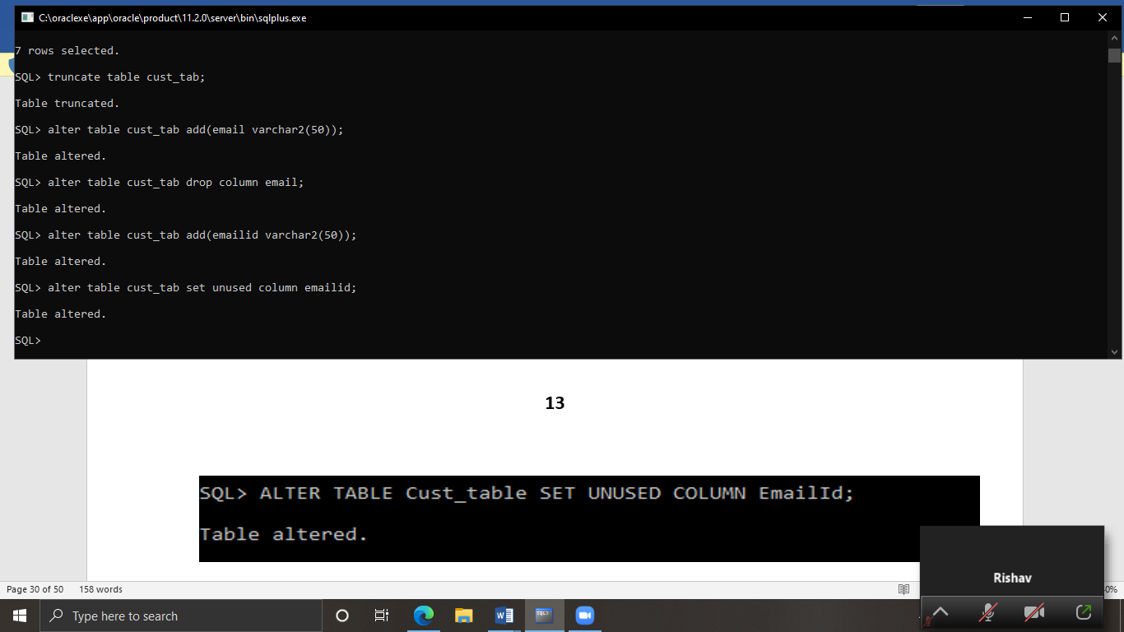

1. alter table cust_tab drop column email;



1. alter table cust_tab add(emailid varchar2(50));



1. alter table cust_tab set unused column emailid;



1. alter table cust_tab drop unused columns;

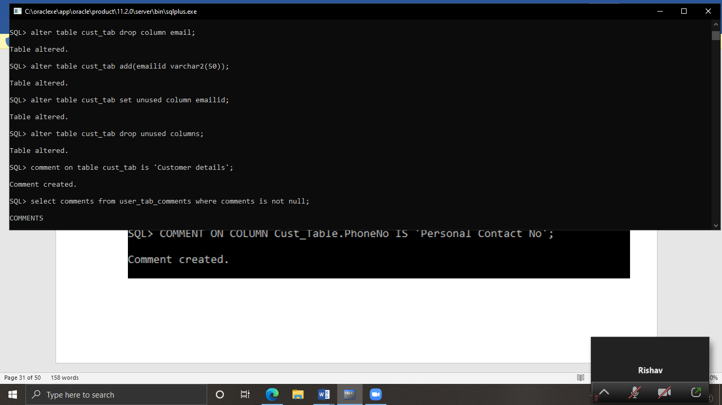

1. comment on table cust_tab is 'Customer details';



1. select comments from user_tab_comments where comments is not null;

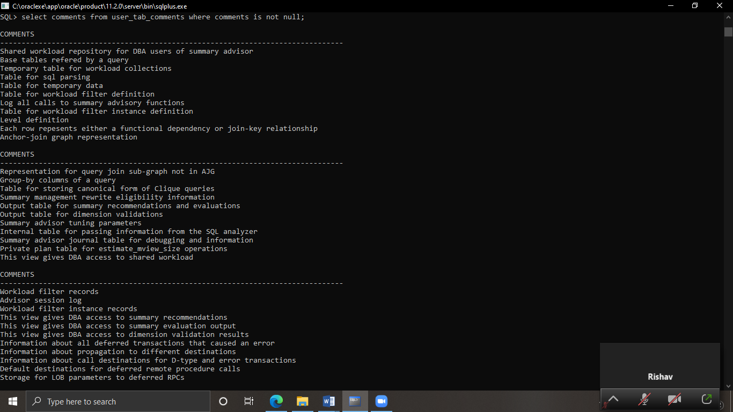

1. comment on column cust_tab.phoneno is 'Personal Contact No';

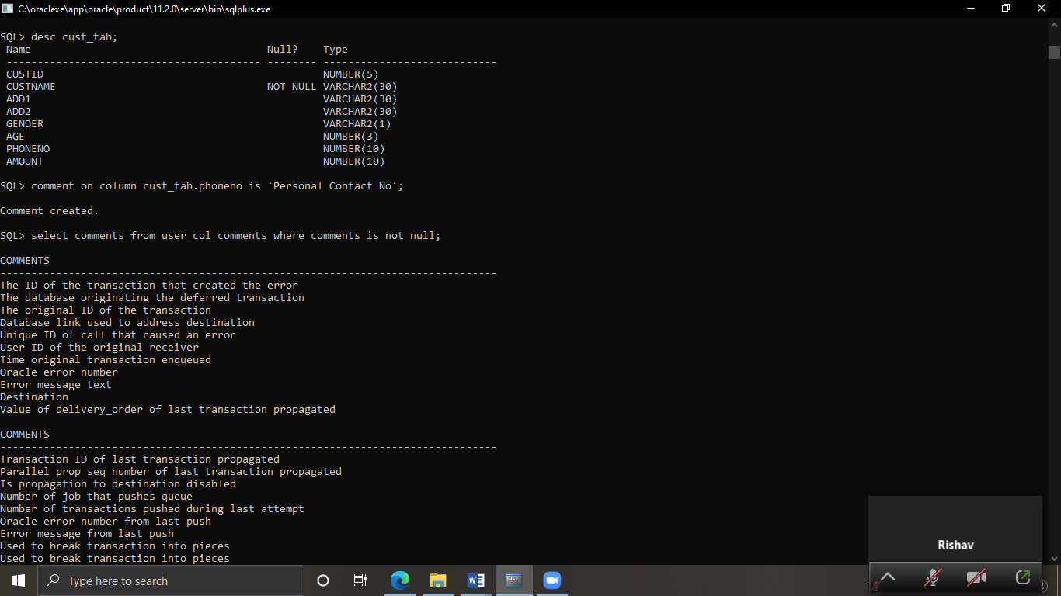

1. select comments from user_col_comments where comments is not null;

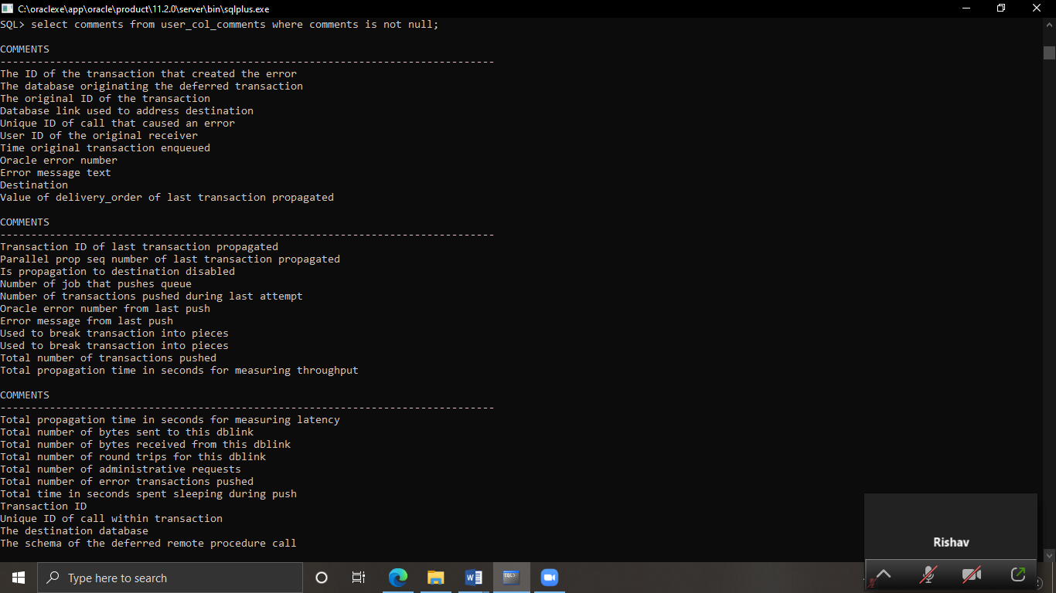

1. create table supp_tab(suppid number(5),sname varchar2(30) not null, add1 varchar2(30),add2 varchar2(30), contactno number(10));

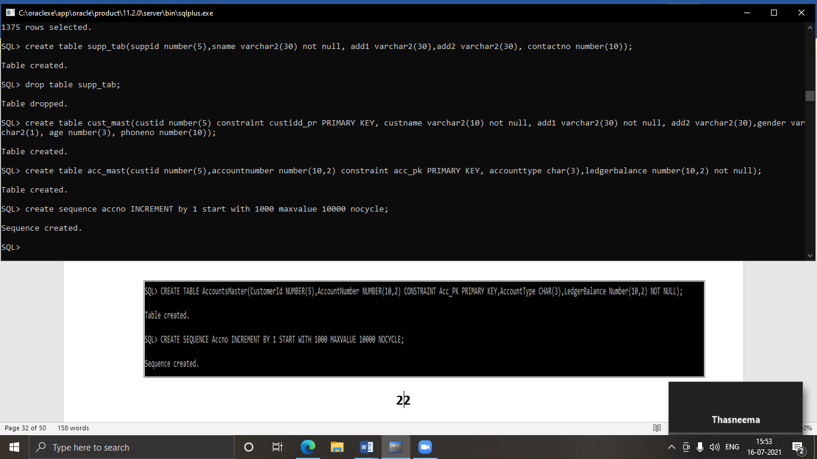

1. drop table supp_tab;

create table cust_mast(custid number(5) constraint custidd_pr PRIMARY KEY, custname varchar2(10) not null, add1 varchar2(30) not null, add2 varchar2(30),gender varchar2(1), age number(3), phoneno number(10));



1. create table acc_mast(custid number(5),accountnumber number(10,2) constraint acc_pk PRIMARY KEY, accounttype char(3),ledgerbalance number(10,2) not null);

create sequence accno INCREMENT by 1 start with 1000 maxvalue 10000 nocycle;



1. alter table acc_mast add constraint cust_acc FOREIGN KEY (custid) REFERENCES cust_mast (custid);

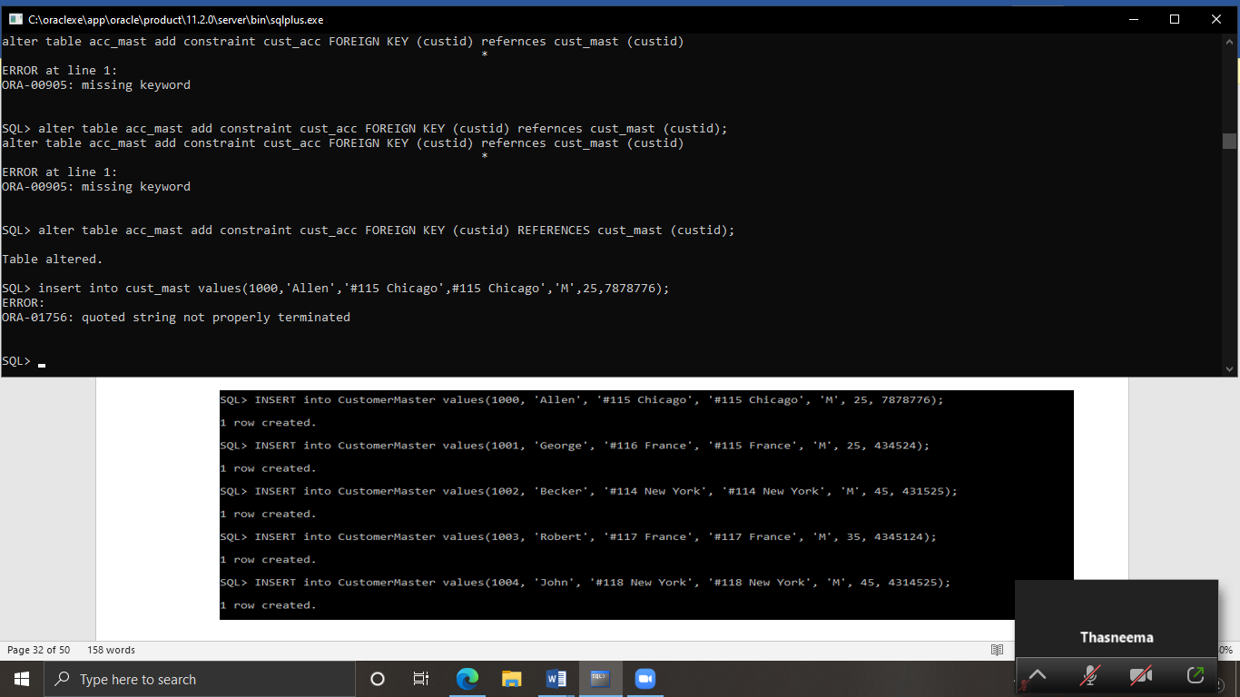

1. insert into cust_mast values(1000,'Allen','#115 Chicago','#115 Chicago','M',25,7878776);

insert into cust_mast values(1001,'George','#115 France','#115 France','M',25,434524);

insert into cust_mast values(1002,'Becker','#114 New York','#114 New York','M',25,431525);

insert into cust_mast values(1003,'Robert','#117 France','#117 France','M',35,4345124);

insert into cust_mast values(1004,'John','#118 New York','#118 New York','M',45,4314525);

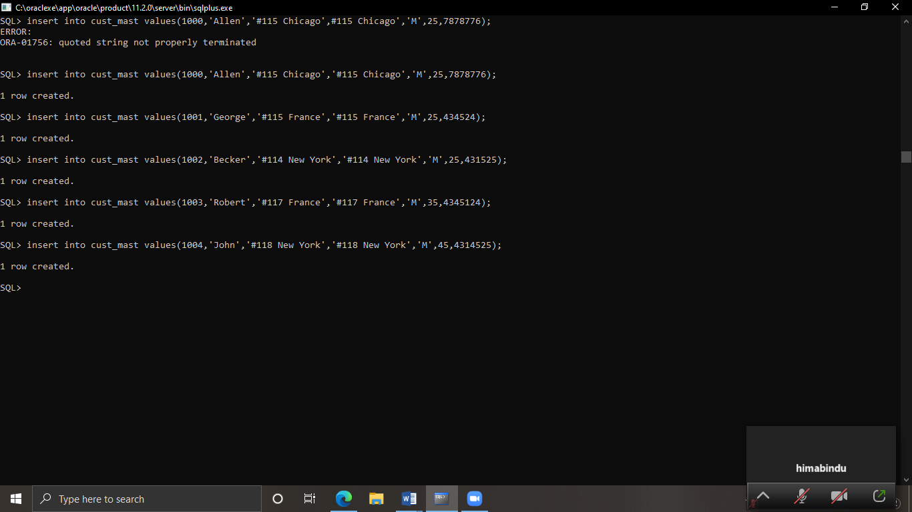

1. alter table acc_mast add constraint accounytype CHECK (accounttype IN ('NRI','IND'));

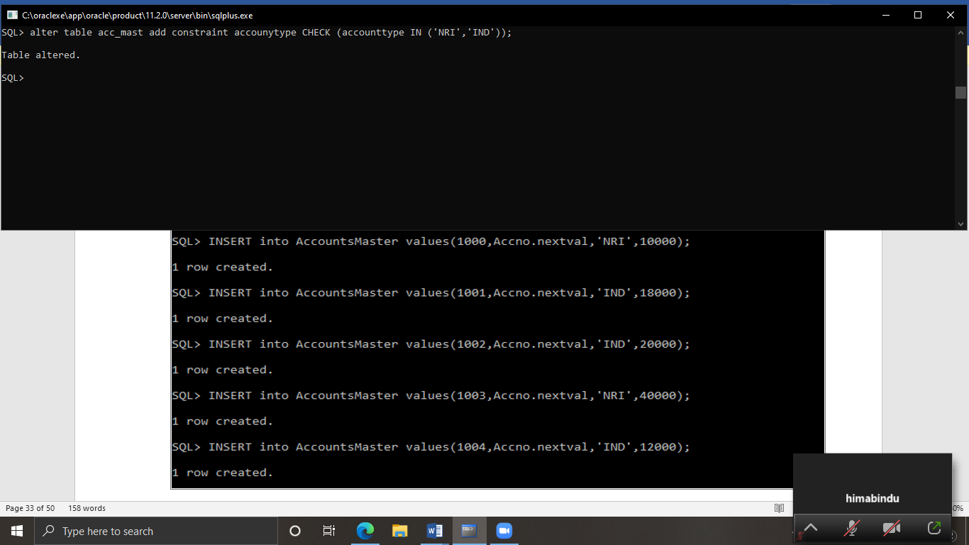

1. insert into acc_mast values(1000,9828,'NRI',10000);

insert into acc_mast values(1001,9348,'IND',18000);

insert into acc_mast values(1002,6748,'IND',20000);

insert into acc_mast values(1003,8629,'NRI',40000);

insert into acc_mast values(1004,7894,'IND',12000);

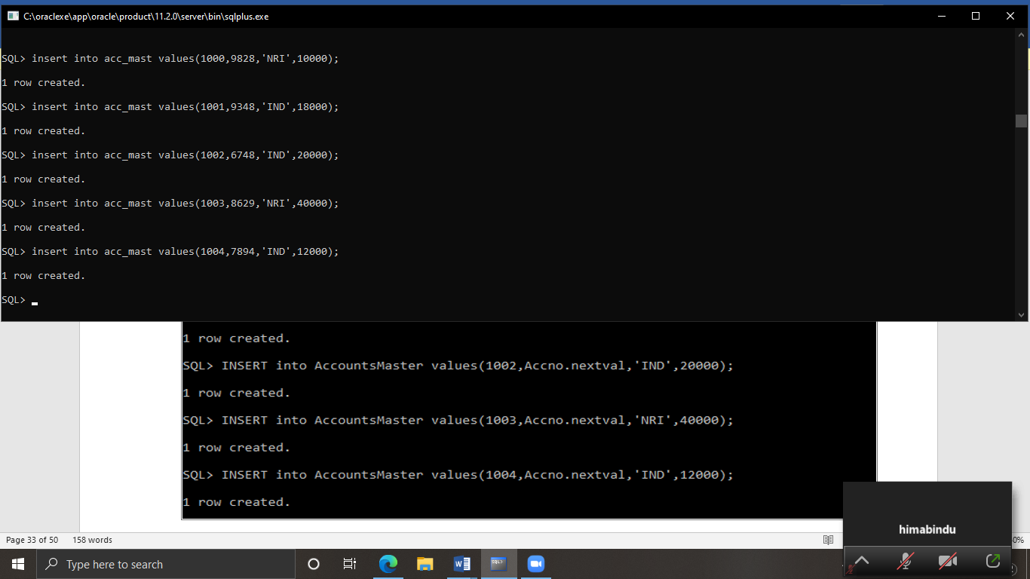

1. alter table acc_mast add constraint Bal_check CHECK(LedgerBalance>5000);

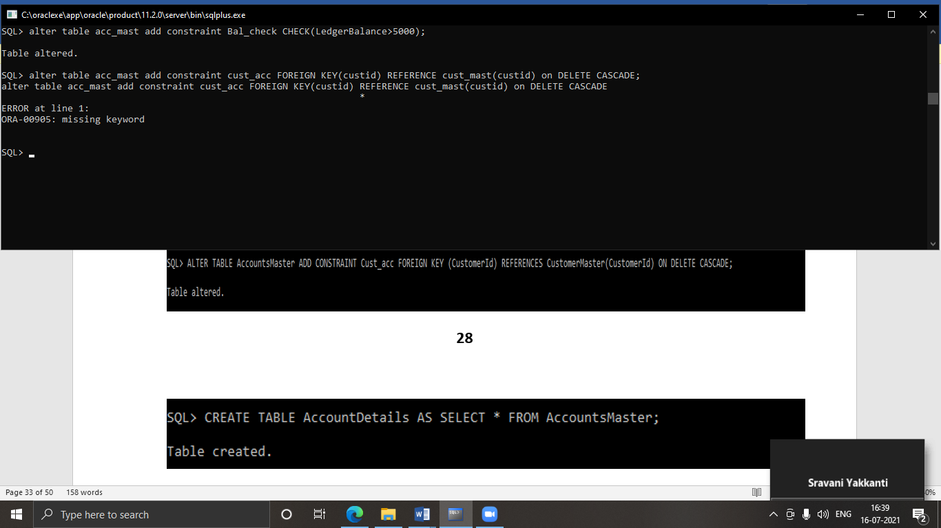

1. alter table acc_mast add constraint cust_acc FOREIGN KEY(custid) REFERENCES cust_mast(custid) on DELETE CASCADE;

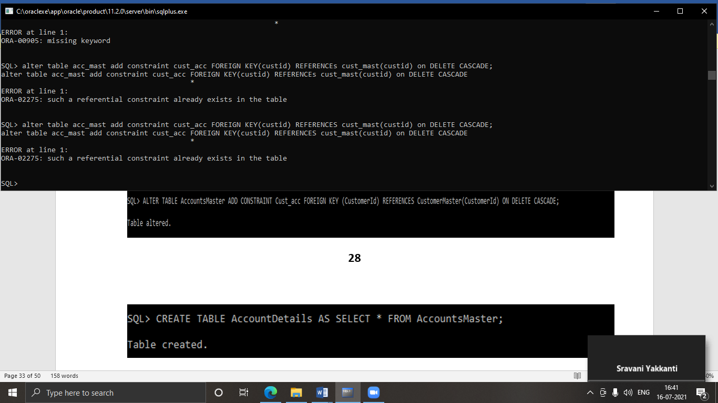

1. create table AccountDetails as select * from acc_mast;

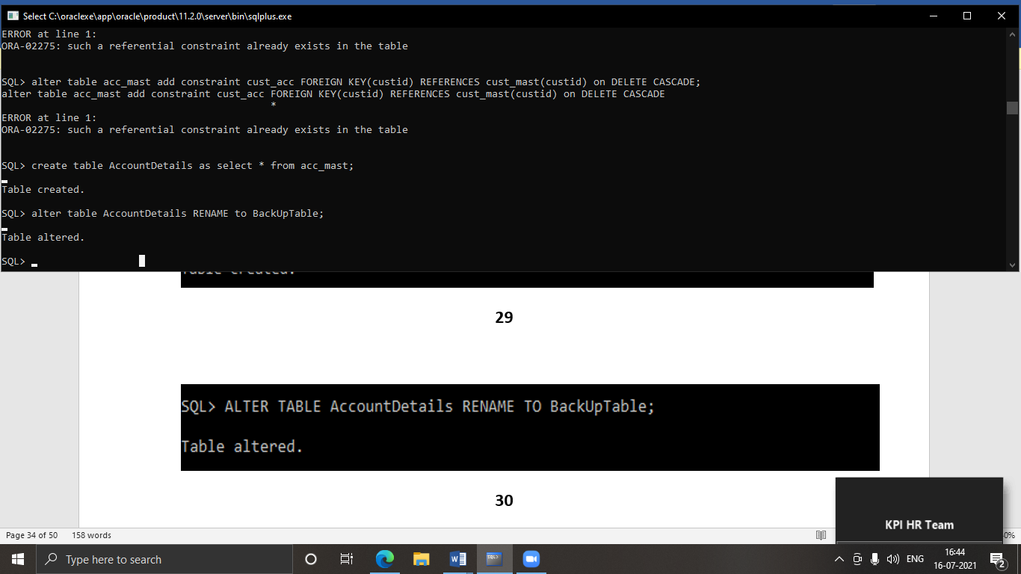

1. alter table AccountDetails RENAME to BackUpTable;



1. create view acc_view as select acc_mast.custid as custmoercode,custname as accountholdername,accountnumber as accountnumber,accounttype as type,ledgerbalance as balance from acc_mast JOIN cust_mast on cust_mast.custid=acc_mast.custid;

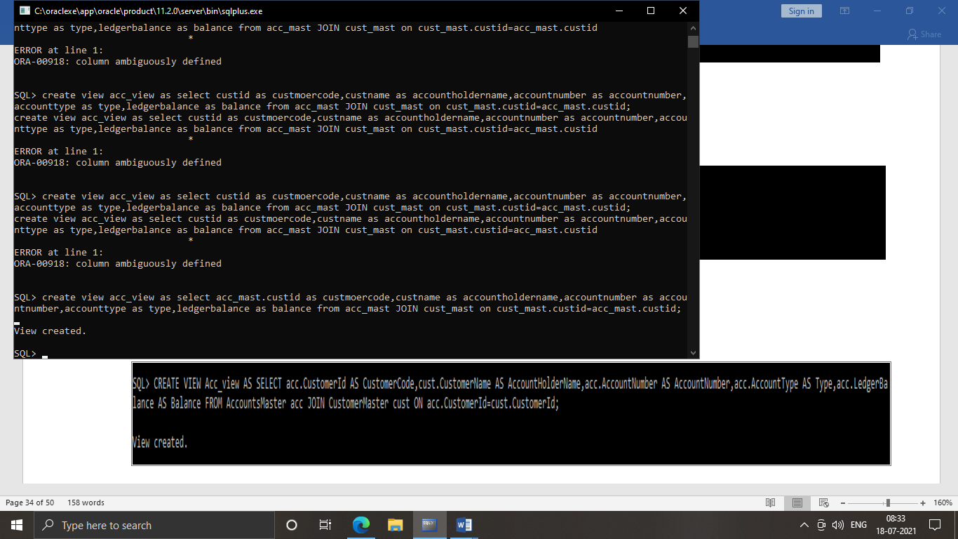

1. create view Acc_Details as select * from acc_mast where accounttype='IND'and ledgerbalance>1000 with CHECK OPTION;

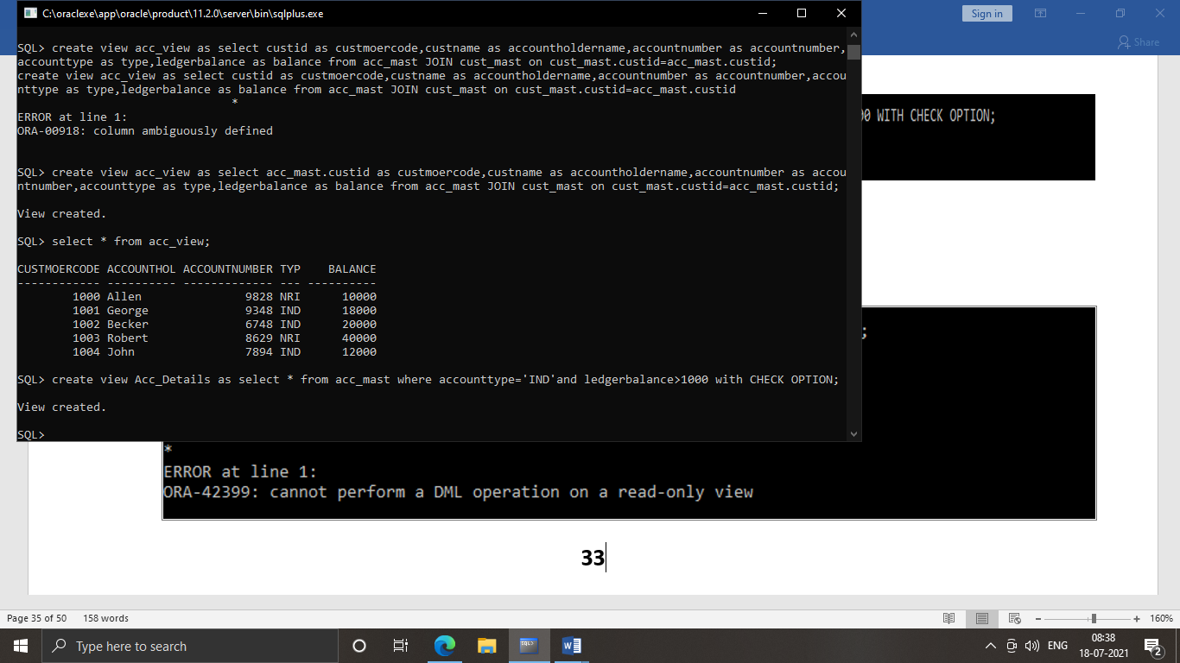

1. create view accsvw10 as select * from acc_mast WITH READ ONLY;

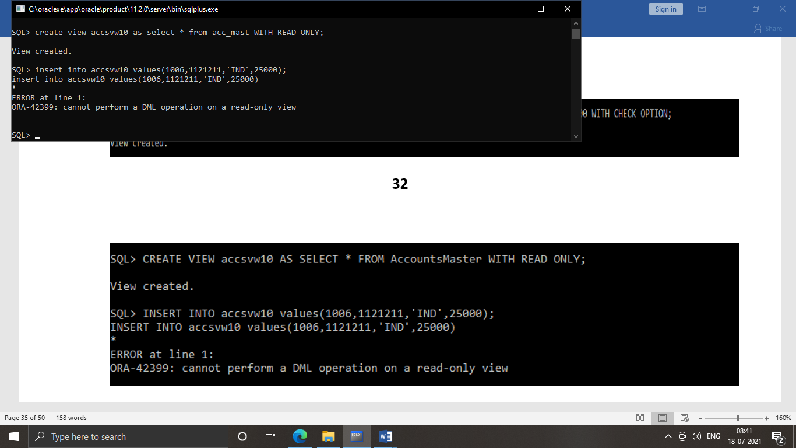

1. select dept_name from(select dept_code,max(staff_sal) from staff_masters group by dept_code order by staff_sal desc) staff_masters JOIN department_masters on staff_masters.dept_code=department_masters.dept_code where rownum<=1;
2. select sm.staff_name,dm.dept_name from (select sm.staff_name,sm.dept_code,max(staff_sal) from staff_masters sm group by sm.dept_code,sm.staff_name order by sm.staff_sal desc) staff_masters sm join department_masters dm on sm.dept_code=dm.dept_code where rownum<=2 order by dm.dept_name;
3. create sequence seq_dept increment by 10 start with 40 maxvalue 200 nocycle;

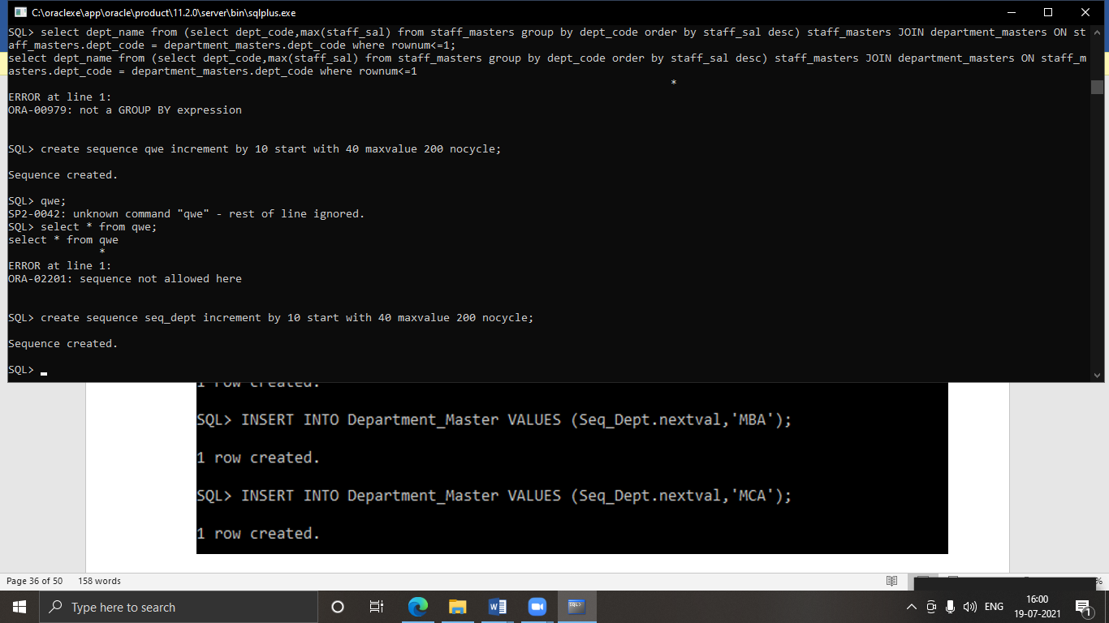

1. create table dept_tab(dept_code number(10),dept_name varchar2(10));

insert into dept_tab values(seq_dept.nextval,'MBA');

insert into dept_tab values(seq_dept.nextval,'MCA');

insert into dept_tab values(seq_dept.nextval,'MS');

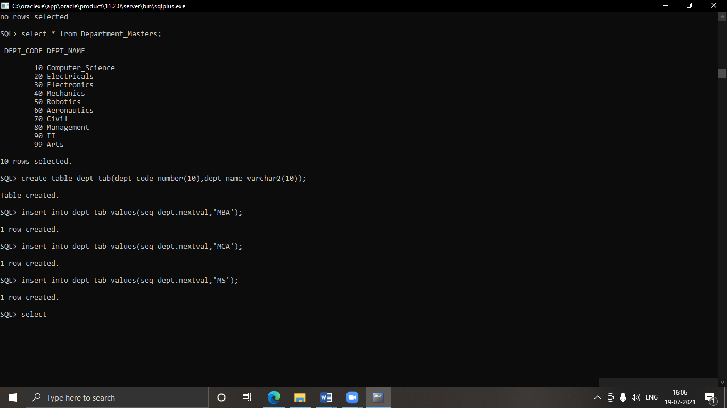

1. alter sequence seq_dept increment by 5;

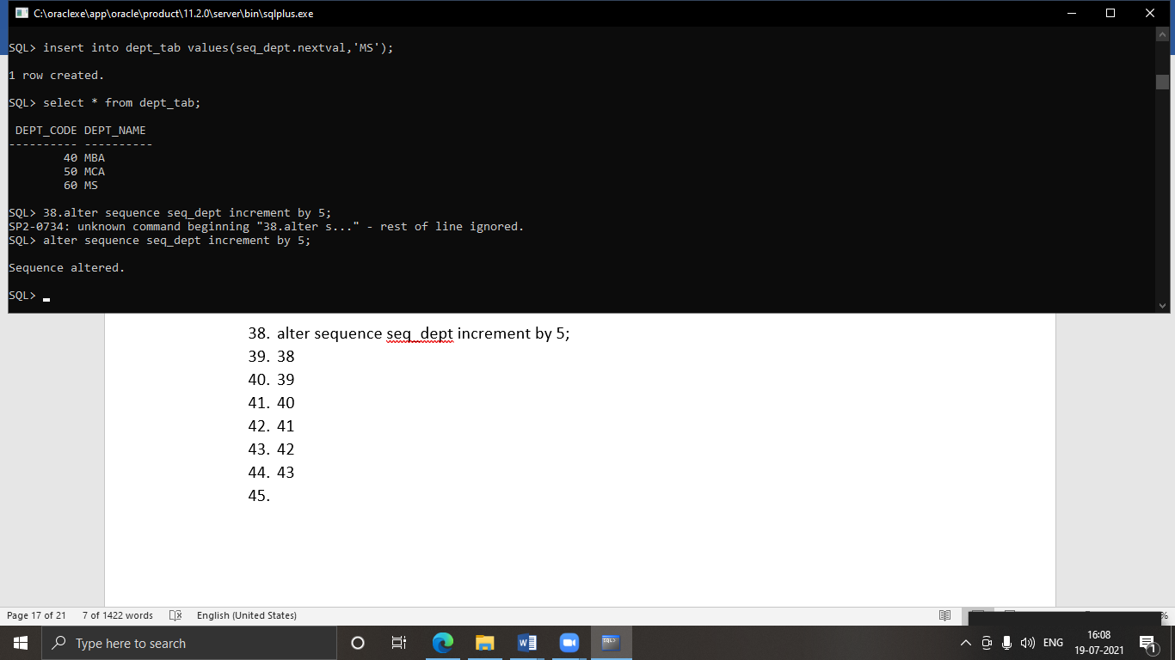

1. drop sequence seq_dept;

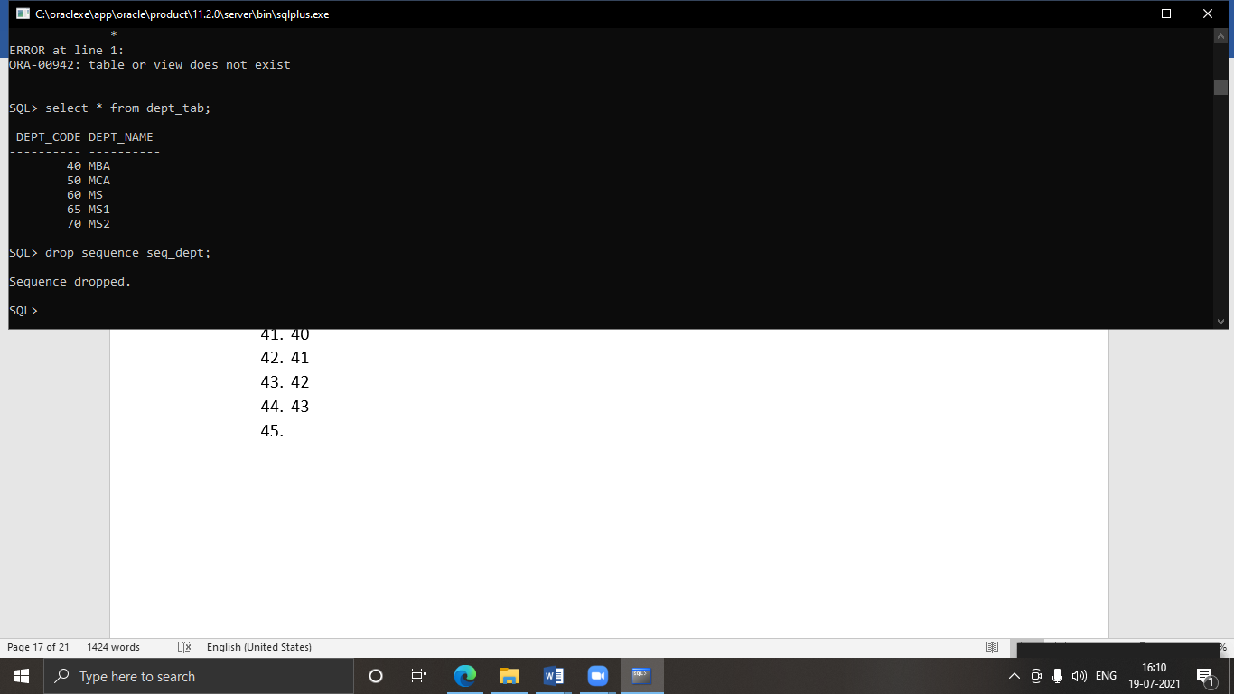

1. create UNIQUE INDEX No_Name on dept_tab(dept_code,dept_name);

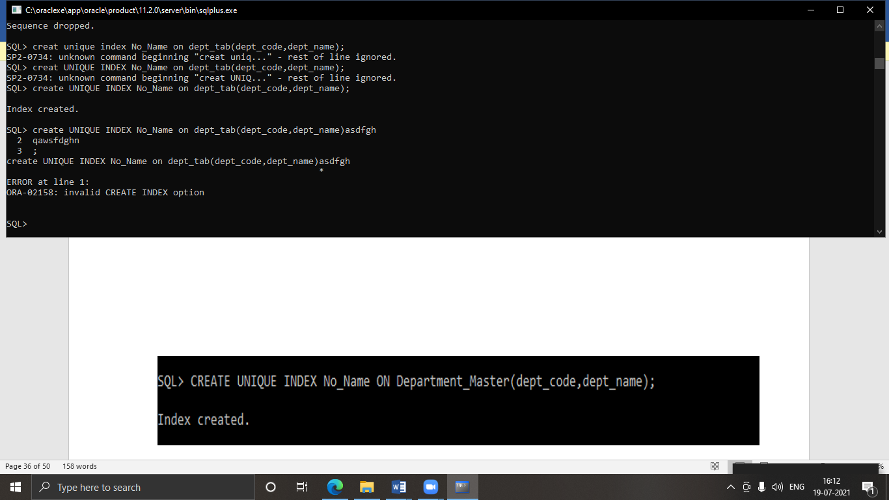

1. select * from all_indexes where index_name='N0_NAME';

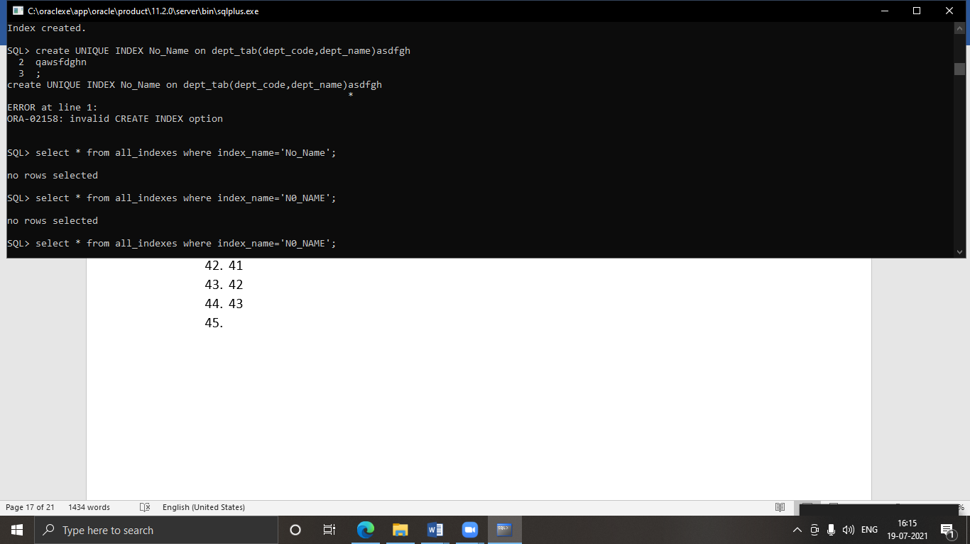

1. create public synonym synon for emp;

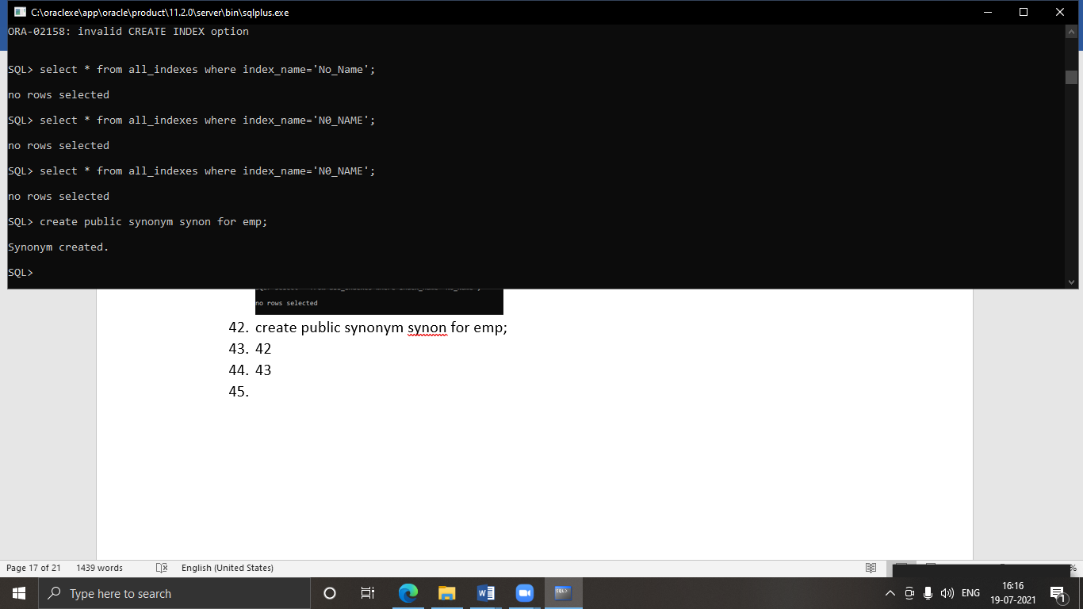

1. select * from all_synonyms where synonym_name='synon';

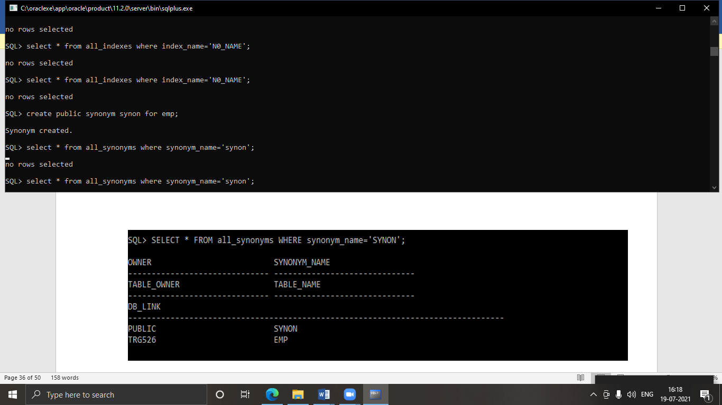

LAB 5 : Data Manipulation Language

1. create table employee (empno number(4) not null,ename varchar2(20), job varchar2(50),mgr number(4),hiredate date,sal number(7,2),comm number(7,2),deptno number(2));

desc employee;

select * from emp;

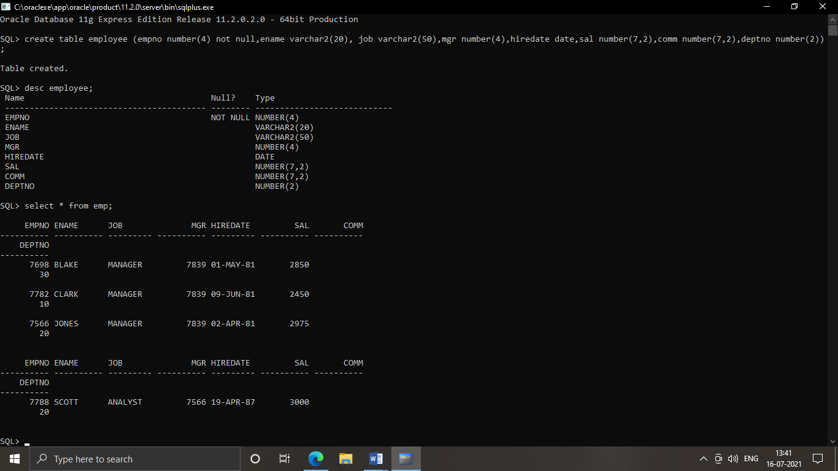

1. select * from emp;



1. update emp set job=(select job from emp where empno=7788), deptno=(select deptno from emp where empno=7788) where empno=7698;

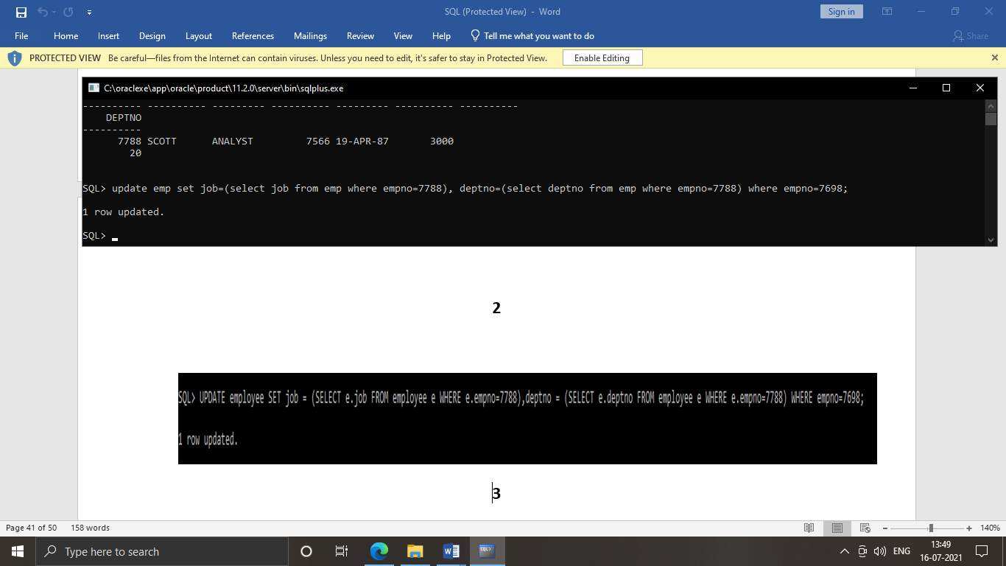

1. insert into dept values(90,’salles’,’BOSTON’)

delete from dept where dname = ‘salles’;

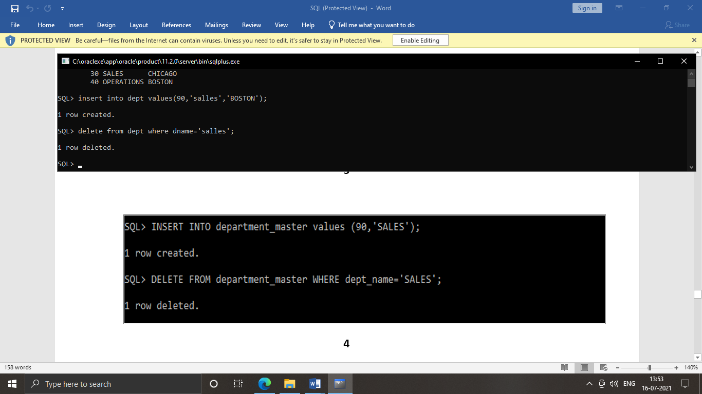

1. update emp set deptno = (select deptno from emp where empno=7698) where empno=7788;

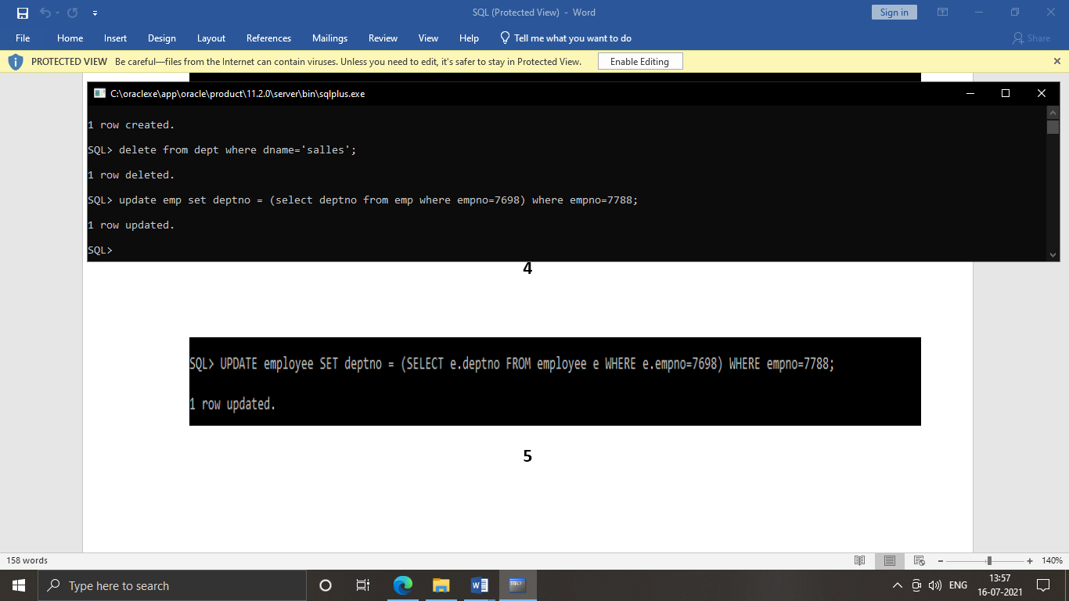

1. insert into emp values(&empno,'&ename','&job',&mgr,'&hiredate',&sal,&comm,&deptno);

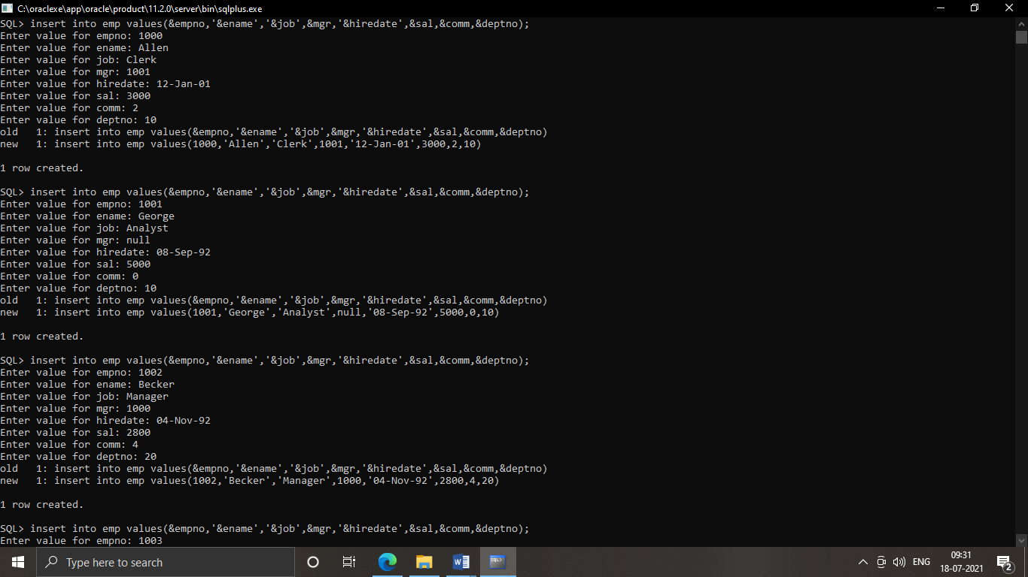

LAB 6: TCL (TRANSACATIONAL CONTROL LANGUAGE)

1. insert into cust_mast values (&custid,'&custname','&add1','&add2','&gender',&age,&phoneno,&amount);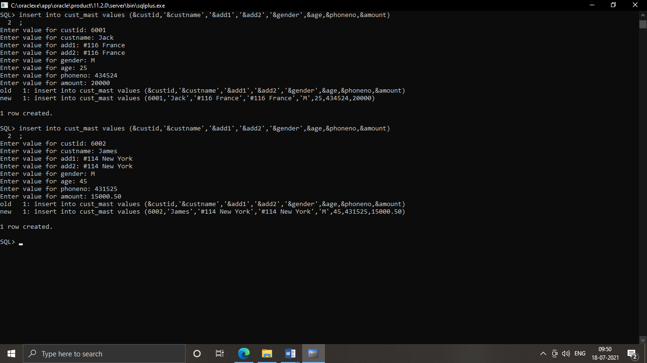

2.savepoint sp1

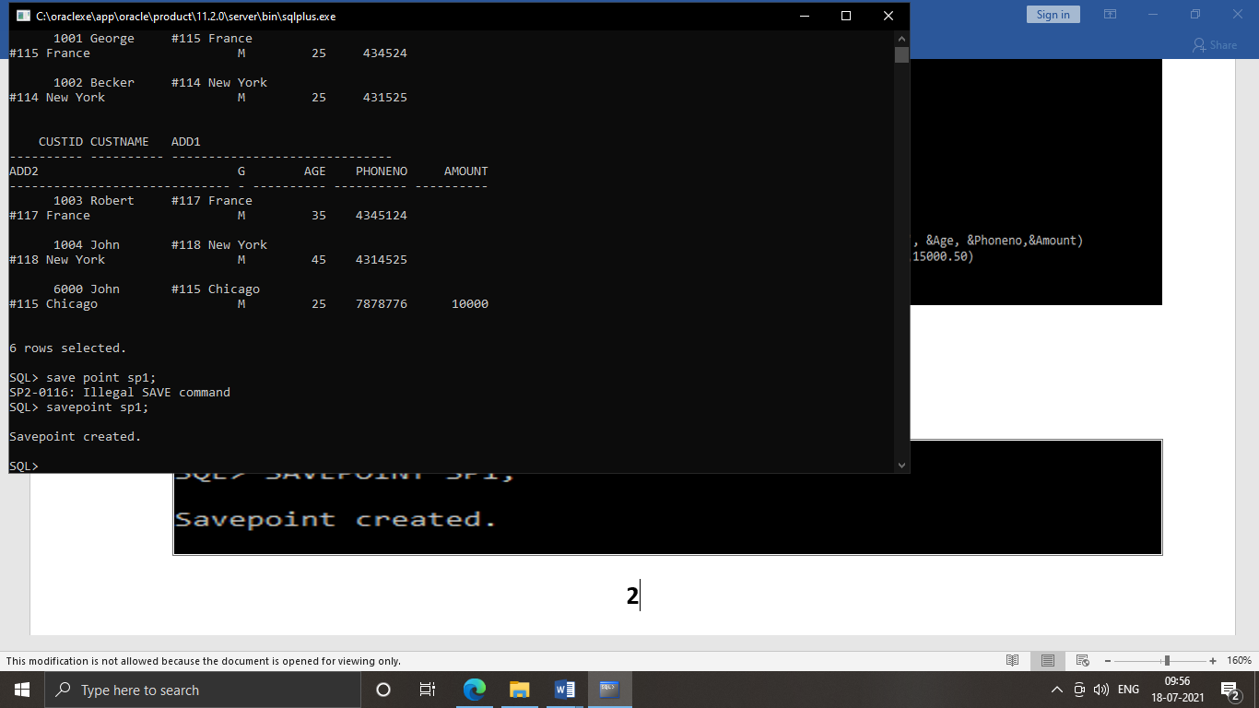

3. insert into cust_mast values (&custid,'&custname','&add1','&add2','&gender',&age,&phoneno,&amount);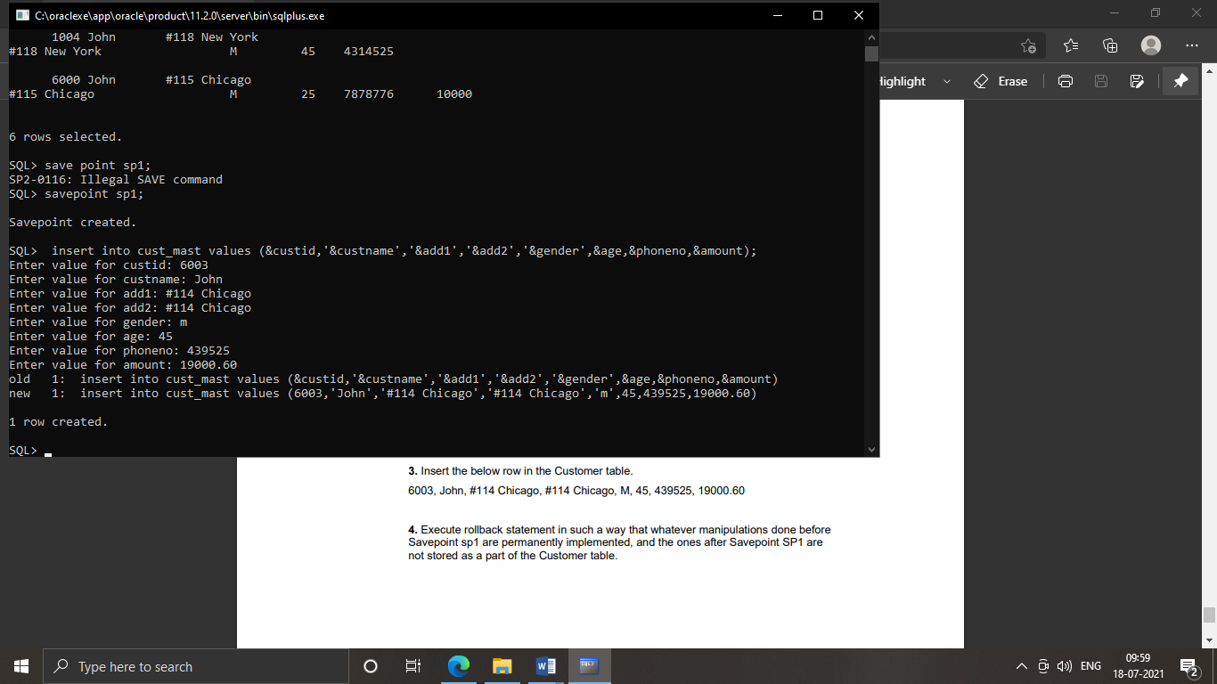

4. rollback to sp1;

commit ;

